Programming errors

Error in python | Error type | Reasons and how to solve
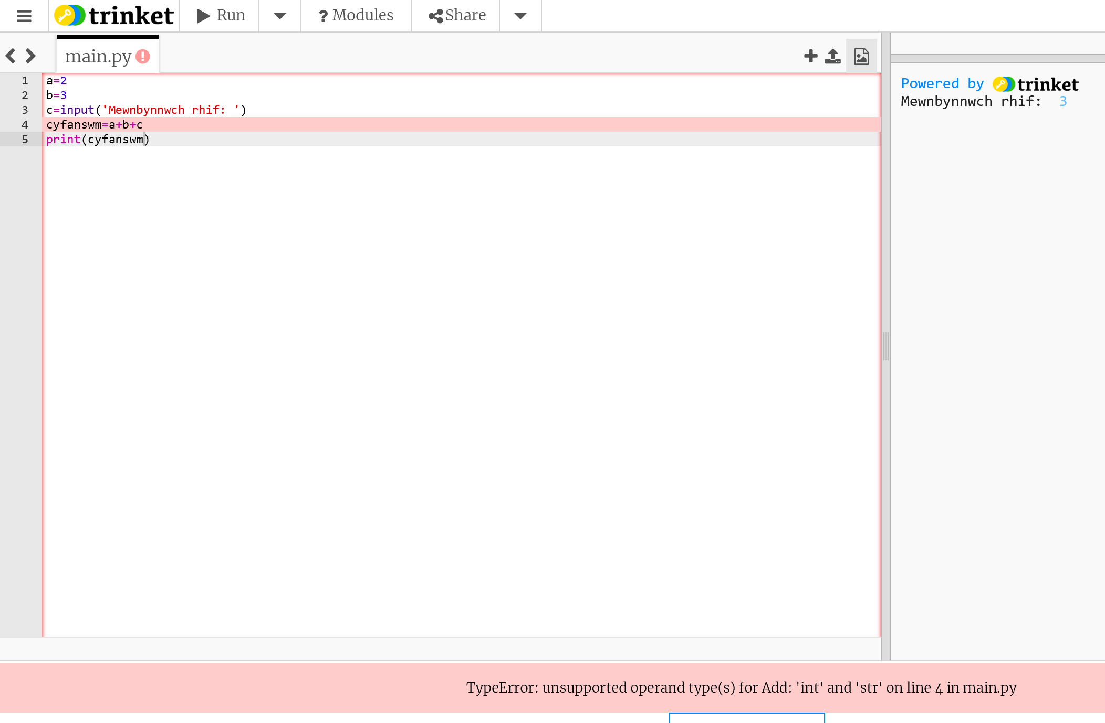 | Runtime/  execution | Only raised when the program is running.  Variable c needs to be turned into an integer - c=int(input(‘Input number: ))
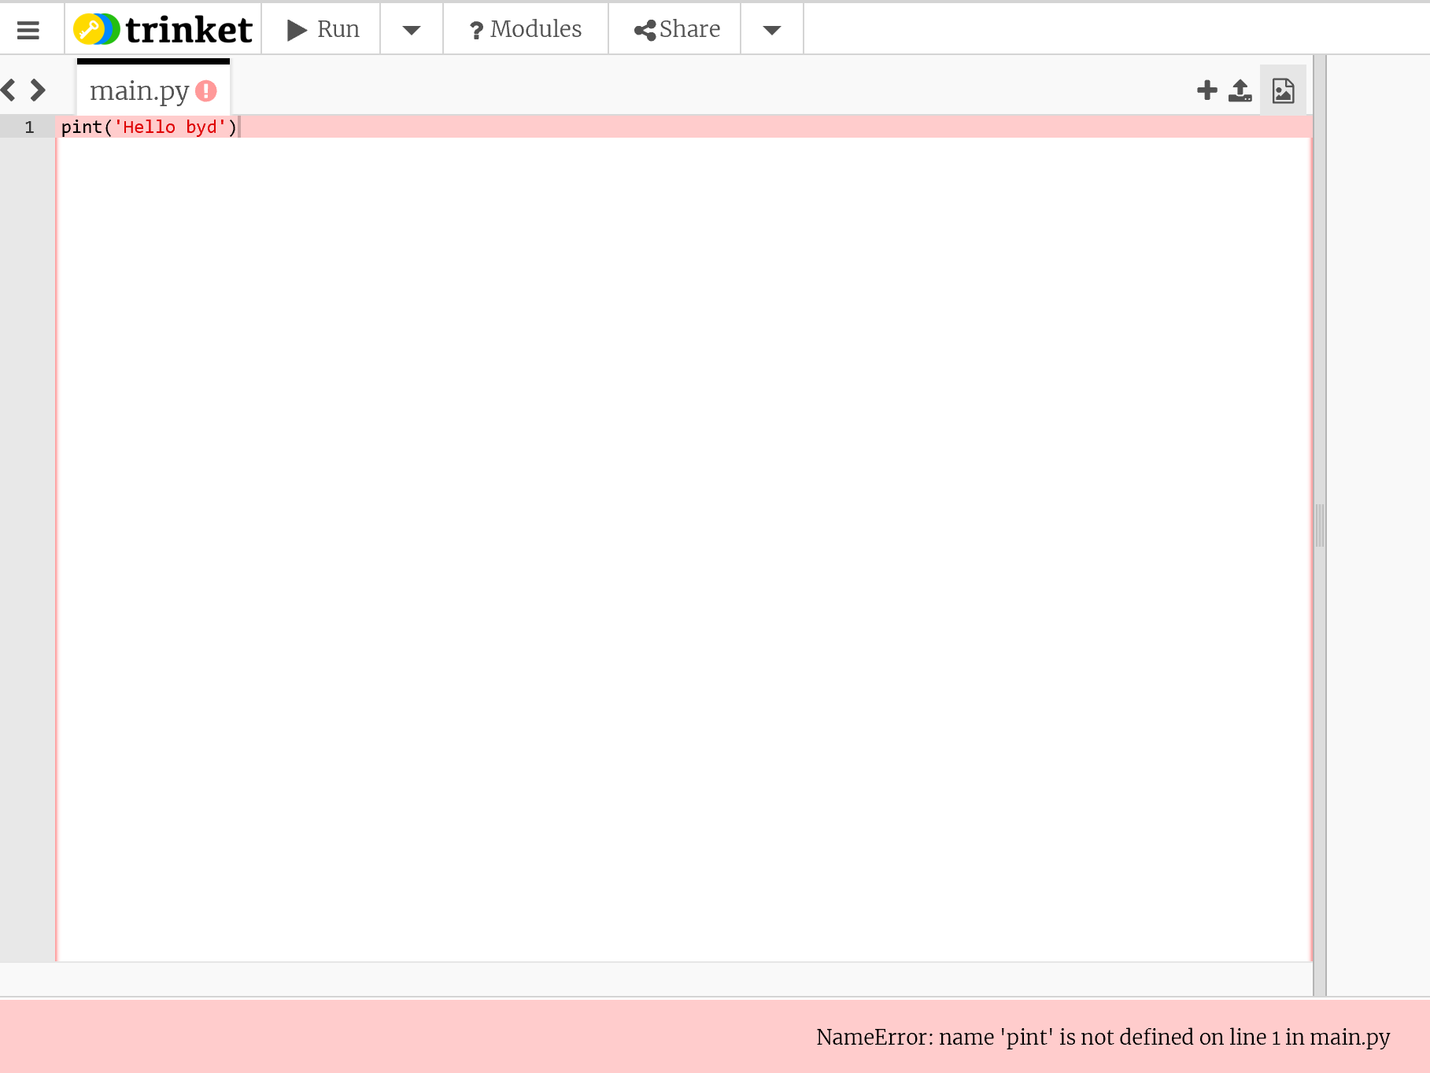 | Syntax | ‘pint’ does not follow the expected language syntax.  ‘pint’ needs to be changed to ‘print’.
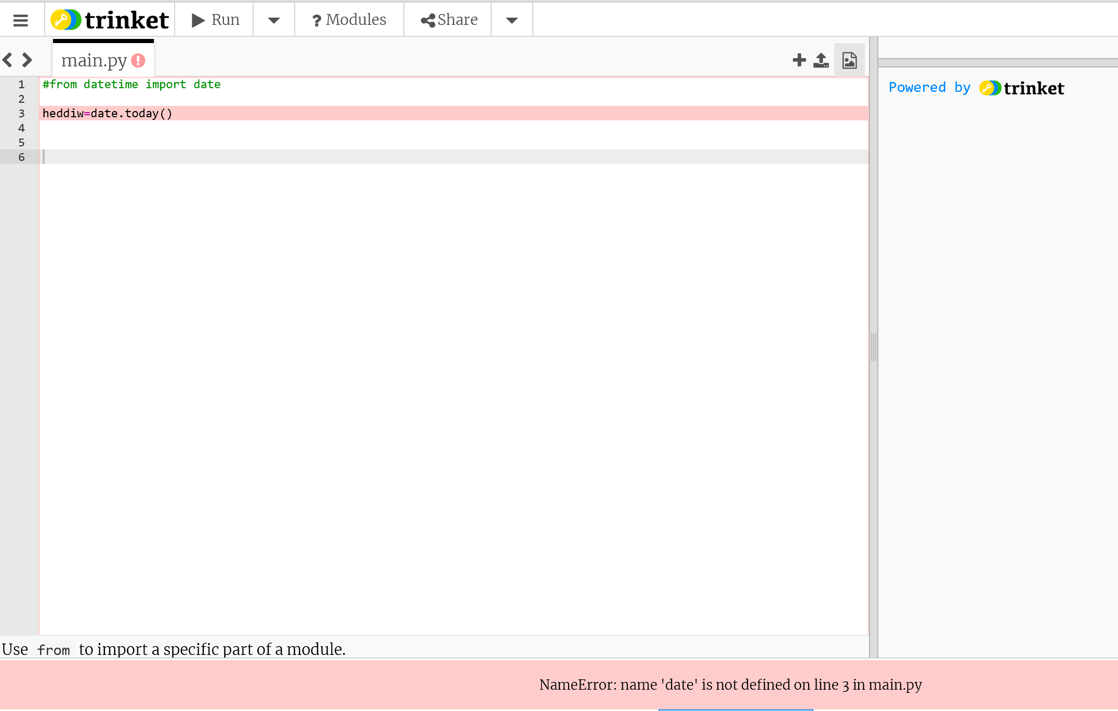 | Connection | Trying to call function ‘time’ from library ‘datetime’, but library is not connected correctly.  Delete comment from first line.
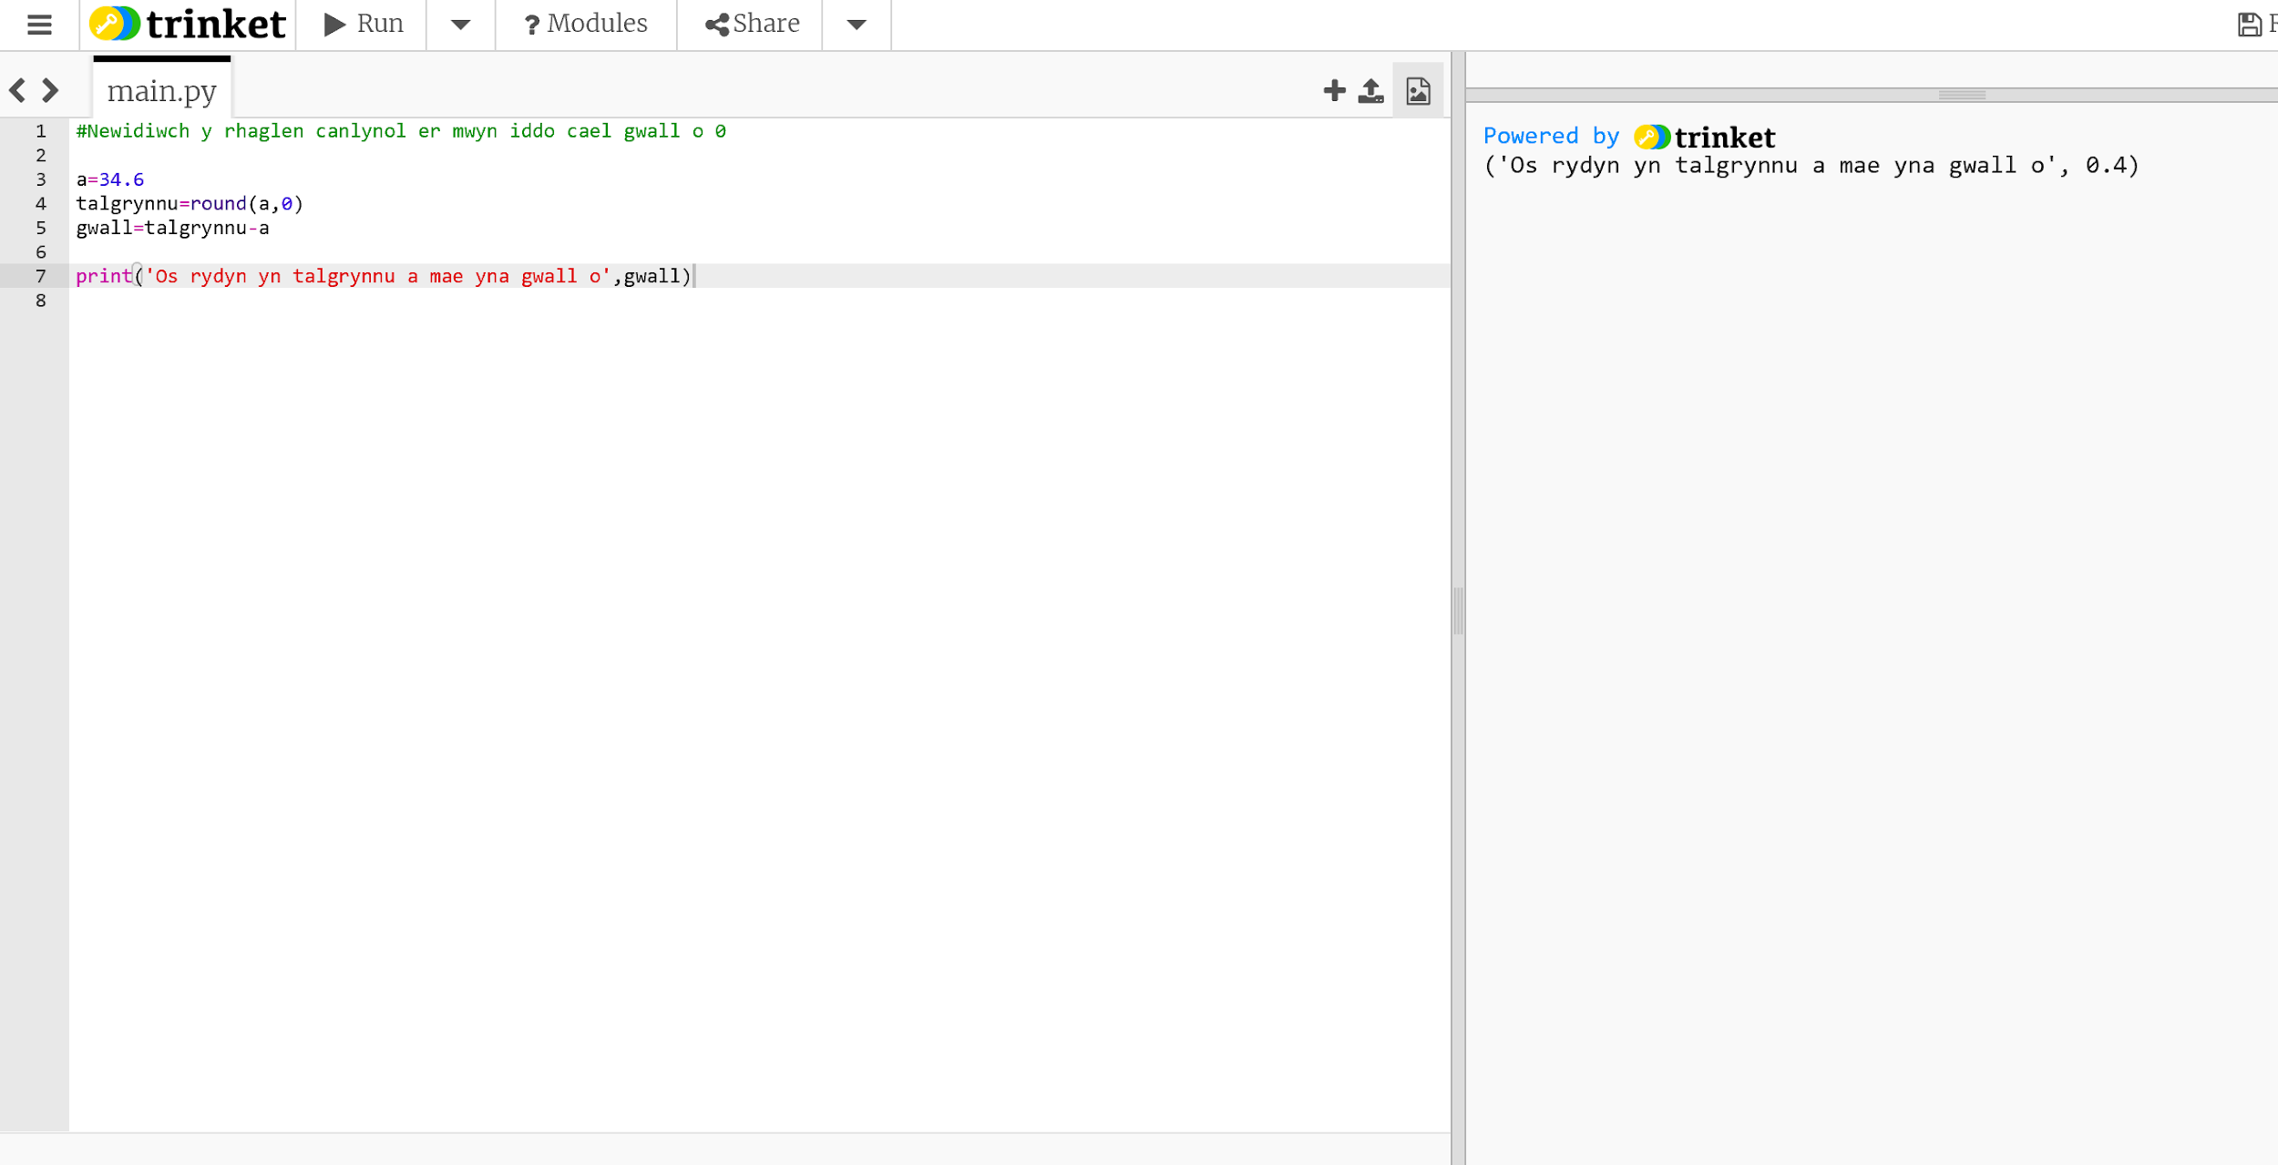 | Rounding | 34.6 rounded to 35 leaving an error of 0.4 (35-34.6).  Need to delete the function round().
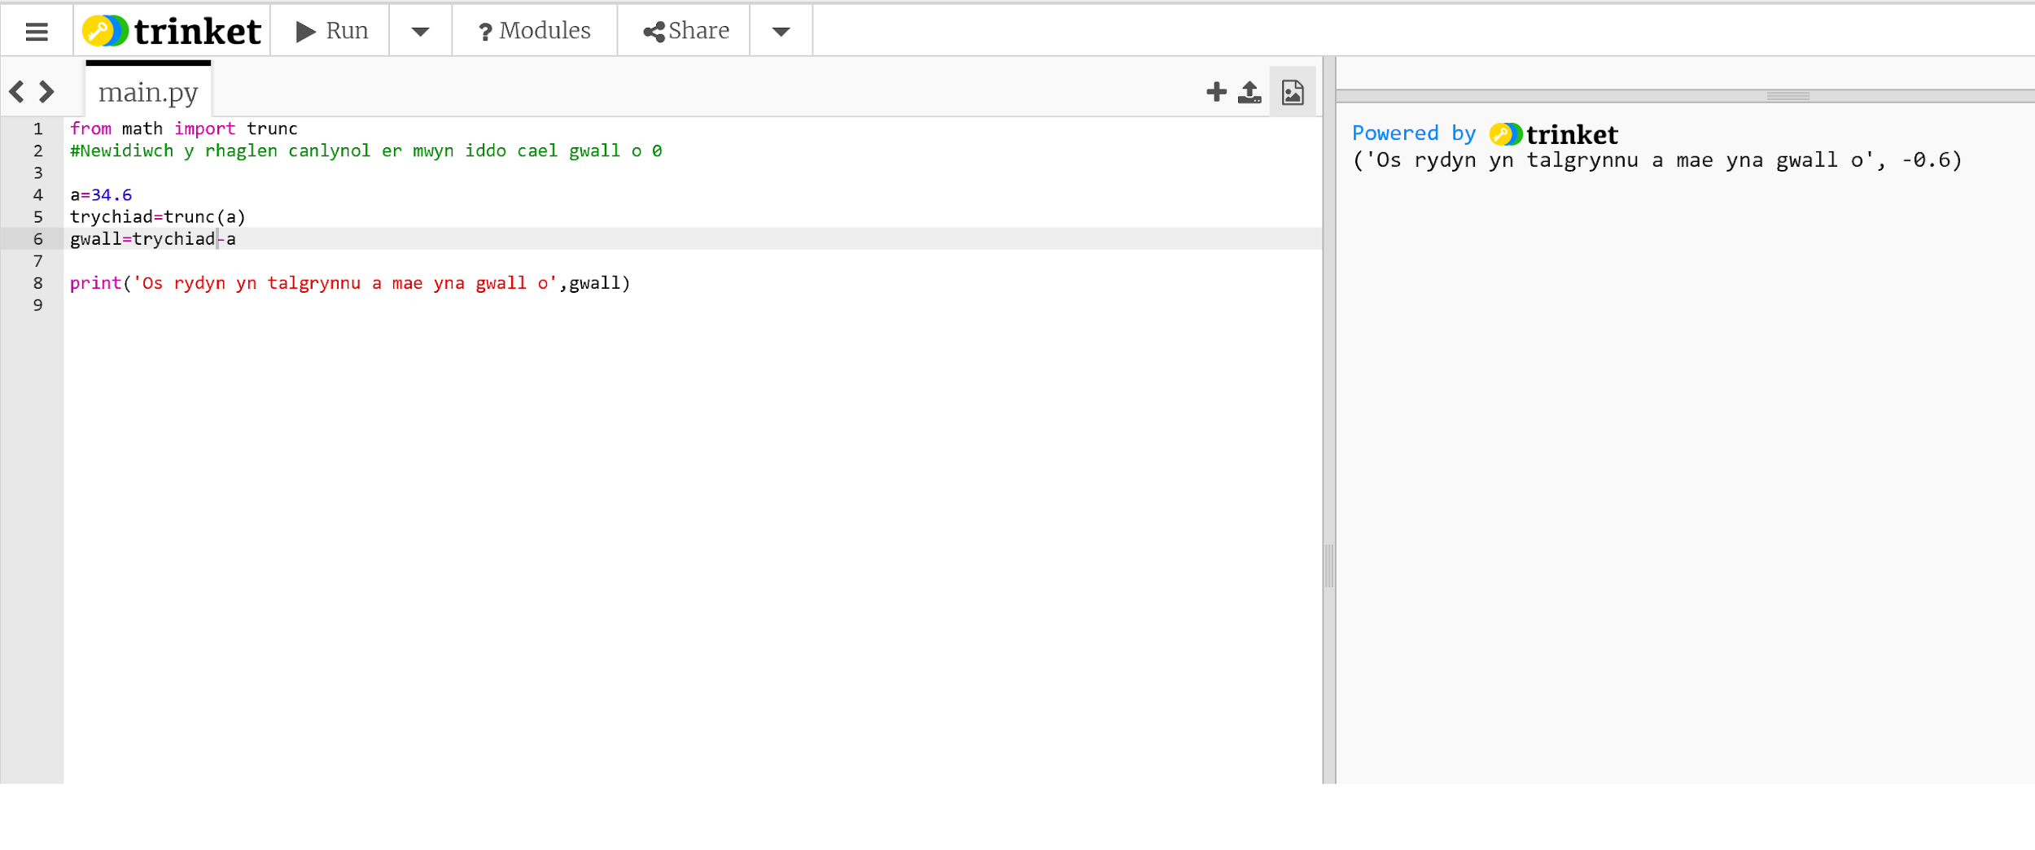 | Truncation | 34.6 truncated to 34 so an error of -0.6. (34-34.6).  Need to delete the function trunc().
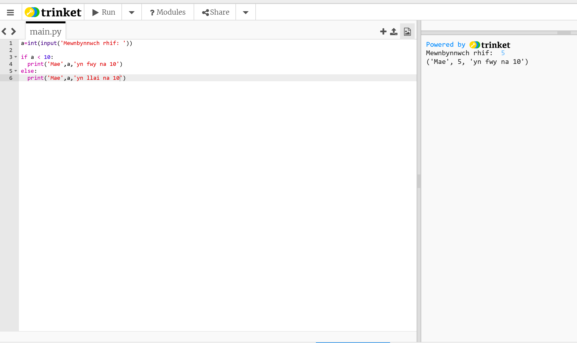 | Logical | The algorithm outputs the incorrect answer e.g. 5 is not greater than 10.  Change the operation < i > in the if statement.  if a > 10:

