GCSE Business 3

Business Operations

Index

Business operations – 1 Methods of production – 2 Quality – 10
The supply chain – 17 The sales process – 33

Business operations
A business has to organise and manage its resources and its key functions in order to carry out its activities and operations. The way in which these are organised will depend on what the business produces or sells, the market they operate in, and the scale at which the business operates.

Operations management is particularly important for manufacturers; businesses that take raw materials and/or components and turn them into finished products either for consumer or producer customers. However, it is also important for service industries, as they also need to efficiently organise their resources in order to give their customers a good experience and to make a profit.
This section will look at:
- Methods of production
- Quality
- The supply chain
- The sales process

Methods of production

Production is the process of turning raw materials, components and other resources into a product or service that can be sold. A business must decide how to organise production. How a business organises its production will depend on some key questions:
- Should each product or service be produced separately?
- Should the product or service be produced in batches?
- Should the product or service be produced continuously?
The decision will be influenced by:
- Cost – which is the cheapest method of production?
- Quality – which will ensure the right quality of product or service for the customer?
- Quantity – how much needs to be made or provided?
There are three key methods of production a business can use to produce its products:
- Job production
- Batch production
- Flow (mass) production

Job production
Job production involves making one product or providing one service at a time in order to meet the specific requirements of the customer. Each product or service will be unique (also known as bespoke) and usually provided to a high quality and at a higher price. Examples of job production include:
- Wedding dresses for a bride are often unique and designed to the specific requirements
of the bride.
- Large construction developments such as bridges and buildings which will be designed
by architects to match the specific requirements of the customer.
- High quality unique furniture using top quality materials and individual designs.

- Hairdresser who will cut the customer's hair to the required style requested from the customer.

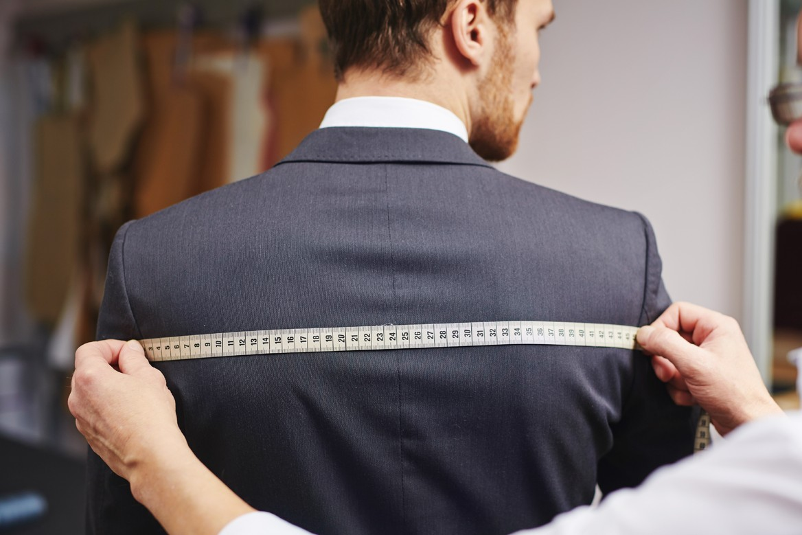

Products manufactured by job production are often produced on a very small scale and by highly skilled workers and can take a long time to complete. For these reasons, plus the fact that the quality of the product and the costs of production is usually very high, products produced this way can be expensive.
The main problems associated with this style of production are:
- Costs per good tend to be high because production runs are short and the workers are highly-skilled and will demand higher wages.

- Specialist equipment will tend to be underused - the worker can only use one tool at a time.
- There is often a lengthy production time.

Jack Lewis is a talented tailor who enjoys making individual shirts and suits for his customers. He works alone in his house. His creations are expensive but in great demand because they are expertly handmade and unique. Jack gets great job satisfaction from his work and he produces one item at a time so he can give it his full attention. Often his
customers will visit him during the production of the garment and Jack will make changes if the customer doesn’t like what he is doing or if they change their mind. Jack is happy to do this as he wants the customer to be happy with what he is making.
- Use the information above to explain why this is a good example job production.
- What are the benefits to the customer of this type of production?
- What are the drawbacks to the customer of this type of production?

Advantages for consumers include:
- Products and services will match consumer tastes and individual requirements.
- Products and services are exclusive/unique so few other people will have similar
products.
- Products will fit in a particular space or be a specific size.

- Products and services will generally be higher quality as goods are made with greater care.
Disadvantages for consumers include:
- Products and services tend to have higher prices than mass-produced products, as more attention is paid in the manufacturing process. Workers tend to have higher skill levels and therefore higher wages.
- Need to wait for products and services as they take longer to complete due to the greater attention to detail and high quality.
- Replacements will be difficult to find as the products were made for a specific purpose to a particular design. This also means that spare parts may also be more difficult to find and may be more expensive.

Batch production
Batch production is when several of the same products are made in one batch, these products will move together through the different stages of production. Each batch is finished before the next batch is started. All the items in the batch are the same, so production is speeded up and the cost of labour is reduced which leads to cost savings, which can be passed onto the customer with cheaper prices.
Examples of products made in batches can include:

- A bakery making batches of bread or cakes, a quantity of dough is made which is then divided into smaller quantities to make bread. The baker will then bake 24 identical loaves of bread in the oven.

- A manufacturer of picture frames setting up its machinery to cut wood to make a batch of A-frames for A4 size pictures then changing the machine to cut wood for a batch of frames for A5 size pictures.
- A clothing manufacturer making different colors and sizes of socks.

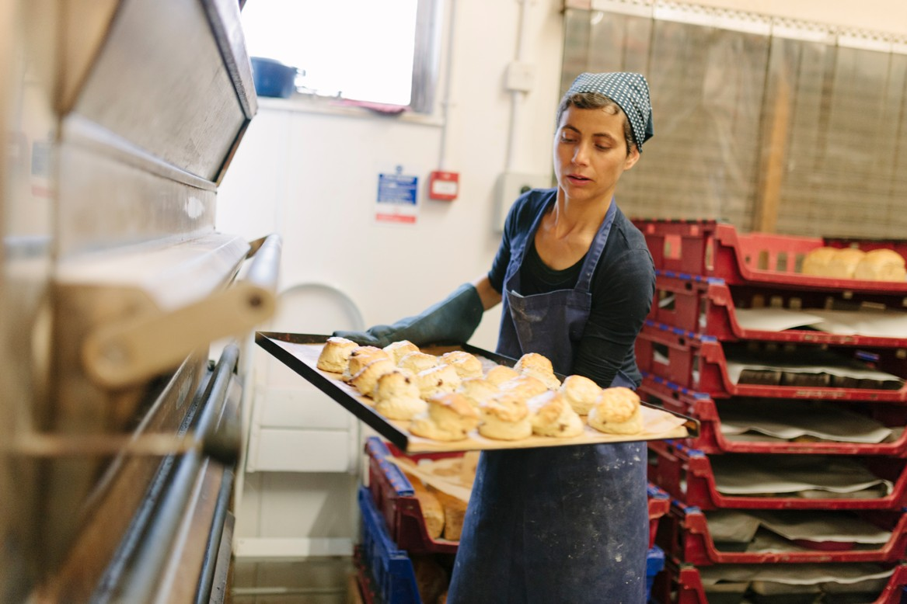

Jack Lewis, the talented tailor who makes individual shirts and suits for his customers has been approached by a local menswear shop. They want him to make 20 suits, all of the same design, but different sizes to sell in their shop. Jack agrees to this and has to employ two temporary workers to help him with the additional work.

- Which method would now be the most appropriate to make the 20 suits? What are the advantages of this method of production?
- Will the price that Jack sells the suits to the shop be the same as he charges for his
unique suits? Explain your answer.

- What might happen to the quality of the 20 suits compared to the individually produced shirts?

Advantages of batch production include:
- More products can be produced to allow for higher sales.
- Costs for producing each product (unit costs) are lower.
- Production is more efficient as workers can specialize in performing specific tasks.
- Specialist machinery can be used to speed up production.

Disadvantages of batch production include:
- Products no longer produced to a unique specification.
- Quality is not as high compared to job production as less time and care is taken on individual products.
- High level of stock may be needed so materials have to be stored and this is expensive.
- Machines have to be cleaned and re-set before producing a different batch - this takes
time and adds to costs.

Flow (mass) production

Flow production is also known as mass production or assembly line production. This is where production takes place as a continuous process. The product flows from one process into the next. This will usually happen where the products made are identical and can be made using a production line method. This method is used in factories and by most modern manufacturers who produce on a large scale. Products are made continuously and in large numbers. Products are identical and allow large quantities to be produced as cheaply as possible.

Each worker adds one part of the finished product as it passes them on the production line, so they become specialised in what they do. Specialist machinery will greatly assist the workers. By specialising in one particular part of the process workers become specialists in their job and this can improve efficiency and reduce costs for the business. Specialisation

involves division of labour, as workers concentrate on specific tasks within a production
process.
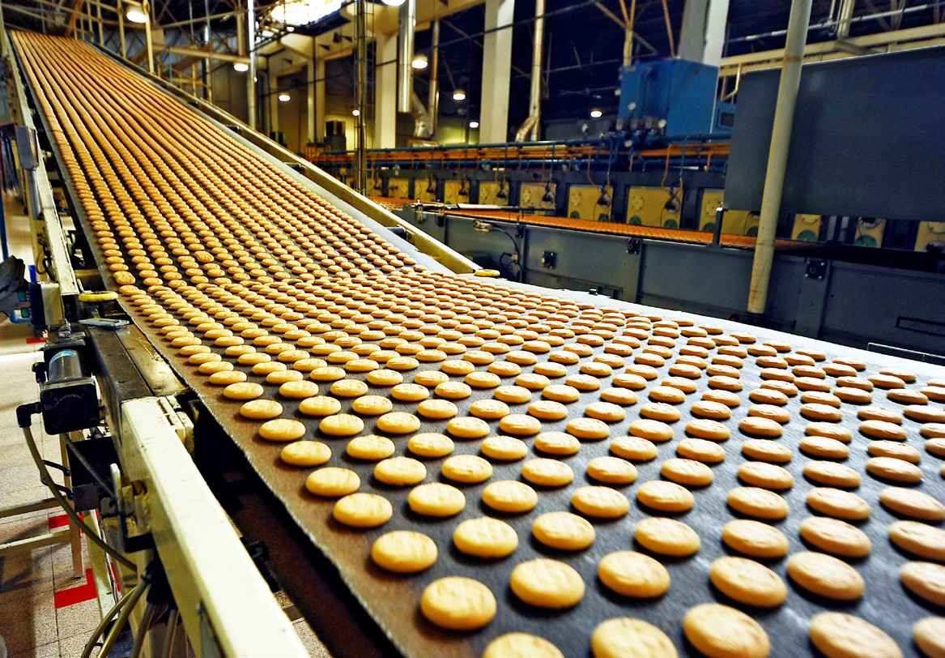
Across the world, consumers are demanding enormous quantities of products and mass production allows businesses to constantly supply products to meet this demand. Most modern consumer goods are produced this way.
Advantages of flow production include:
- High quantities of products can be produced than when using other methods.
- With long production runs, unit costs are low so products can be sold at lower prices.
- Workers can be very skilled at what they do as they are doing the same job over and over.
- Short training periods are required as workers need to be taught only a small number of skills.
Disadvantages of flow production include:
- The high cost of machinery when setting up flow production. Machinery can cost
millions of pounds to purchase.

- Lack of flexibility as flow production produces identical products, what if a customer wanted a slight modification to the product?

Jack Lewis’ suits and shirts have come to the attention of a large retailer who would like Jack to supply 2 000 suits and 4 000 shirts to sell in their 250 stores around the UK. Jack would like to do this but realises his production methods will have to change. He rents a large premises, buys additional machinery and employs 6 permanent workers. He organises the production on an assembly line basis and each of the 6 workers is responsible for their own part of the production process. Although Jack’s profits are higher, he misses the personal contact with customers and that all his suits and shirts are now the same. Jack has now moved into mass production.
- Will the price that Jack sells the suits to the large retailers be the same as the price he
sold to the one shop? Explain your answer.
- What risks does Jack now face? Explain your answer.
- Outline the benefits and drawbacks of mass production for Jack and his customers.

Generally small scale businesses will use job and batch production as they don’t have the resources for the equipment for flow production, or the demand from customers. Many small businesses will look to invest in machinery that allows them to use mass production if they wish to grow and sell more products. Although most large scale businesses, such as multinationals, are likely to use mass production, in order to meet the demand for their
products, some large manufacturers may still use job production and a mixture of batch and
mass production.
When deciding on the most appropriate method of production a business will need to consider:
- The quantity to produce
- The quality expected by the customer
- The cost of investment
- The flexibility of production

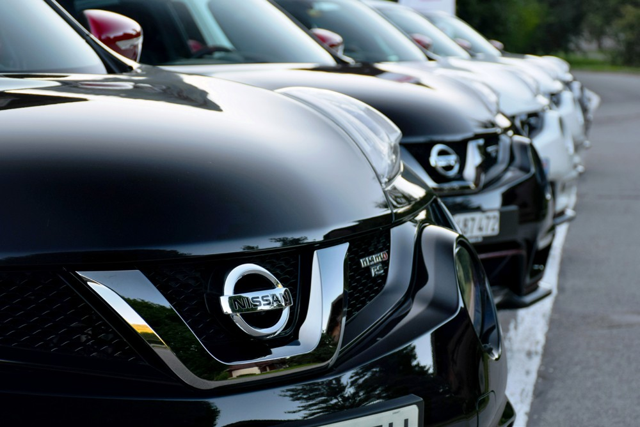
Read the date below and answer the questions that follow:

The Morgan Motor Company is a family-owned British motor car manufacturer which has been producing cars since 1909. Morgan cars are famous for their unique blend of
charisma, quality materials, craftsmanship and performance. Morgan builds around 1 300 cars per year. Morgan retains a highly skilled workforce of around 180 people, with the average length of service at the factory being 25 years.

Morgan is extremely proud of its heritage and has a reputation for excellence, higher standards and the best craftsmanship. Every Morgan is bespoke – tailored to the customer’s specification. The waiting list for a car is approximately six months.
Prospective owners are encouraged to visit them to watch their car being built and to choose from their wide paint and leather-trim ranges, along with the optional extras that will stamp the customer’s own individuality upon their Morgan; every last detail of a Morgan is tailored to the customer’s specification.
Prices range from £30 000 to £80 000 for basic models and the price will increase with any additions that make the car individual and unique for the customer.

Nissan are a major car manufacturer with plants throughout the world. In the UK Nissan has a large factory in Sunderland which employs over 7 000 workers. The factory aims to produce over 600 000 cars a year. Nissan has invested more than £3.7bn in hi-tech
machinery including automated processes and computer-controlled robots, which are vital to production. These machines are maintained and controlled by specialist engineering teams.
The factory is split into three logical areas: Body Assembly, Paint and Final Assembly. Each
area is further broken down into areas known as ‘shops’.

The prices of the cars in the Nissan range are:
- Micra from £10 295
- Note from £12 100
- Juke from £13 420
- Pulsar from £15 995
- Qashqai from £17 995
- X-TRAIL from £22 995
- LEAF from £26 490
- 370Z Coupe from £27 015
- Identify the production methods used by the Morgan Motor Company and Nissan.

- Explain the reasons why the Morgan Motor Company uses this method of production and identify the benefits and drawbacks to their customers.
- Explain the reasons why most large car manufacturers like Nissan use this method of production and identify the benefits and drawbacks to their customers.
- Explain how the working experience for workers at the two companies will differ.

Copy and complete the table below:
Method or production | Definition | 3 advantages | 3 disadvantages | 3 examples
Job production
Batch production
Mass production

Quality

The quality of the product or service is important for businesses. A business must provide these products and services to meet customer expectations. Customers require certain levels of specifications and they will only buy a product or service that meets these expectations.

Consumers are increasingly aware of quality and this is reflected in the objectives of many businesses, for example, the computer manufacturer Dell states: ‘Customers must have a quality experience and be pleased, not just satisfied’.

A quality product or service is one that matches the requirements of the customer. When buying a car from the Morgan Motor Company a high level of quality will be demanded for every aspect of the car, in contrast, buying a basic model mass produced car, the consumer will expect it to work and have some features, but their expectations will be much less.

Quality does not just mean high quality; it means producing a product or providing a service that meets the needs and expectations of the customer, for some products this means the quality will be lower than alternative, higher priced, products or services.

Quality is also defined simply as ‘fitness for purpose’. After all, if the product does the job it was designed to do, it must therefore have some level of quality. Quality does not mean the product or services have to be expensive, it means that it is value for money.

1. With reference to the examples below, explain how a consumer will differ in their expectations of different products:
- Heinz tomato soup and a supermarket own brand version
- Razor sold for £1 and a razor sold for £10
- Service received in McDonalds and service received in a Michelin star winning restaurant

2. Explain why a consumer still expects quality when buying the supermarket own brand soup, a £1 razor and service in McDonalds.

Achieving quality
Achieving quality is a complex task which combines the work of several separate functional
departments within a business. These departments include:

  - Purchasing – ensuring that the right quantity and quality of raw materials or components are available for the production process.
  - Operations – structuring and managing the manufacturing process to reduce errors.

  - Finance – ensuring that capital is available for appropriate investment to have the right equipment.

  - Human resources – ensuring that the labour is available in the right quantities with the right skills and providing suitable training.

- Marketing – providing market research information in order that customer wants can be
satisfied.
There are two main ways a business can achieve quality:
- Quality control
- Quality assurance

Quality control is the more traditional method that businesses have used to manage quality. It involves checking and reviewing work that has been done. Inspection of products and
services takes place during and at the end of the operation process. Quality inspection is carried out to prevent faulty products reaching the customer. This method requires specially trained inspectors, rather than every worker being responsible for his or her own work.

There are three main points during the production process when inspection is carried out:
- When raw materials are received
- Specific stages of the production process
- When products are finished – inspection or testing takes place before products are
despatched to customers.

A major problem is that individuals are not necessarily encouraged to take responsibility for the quality of their own work; someone else will check the quality.

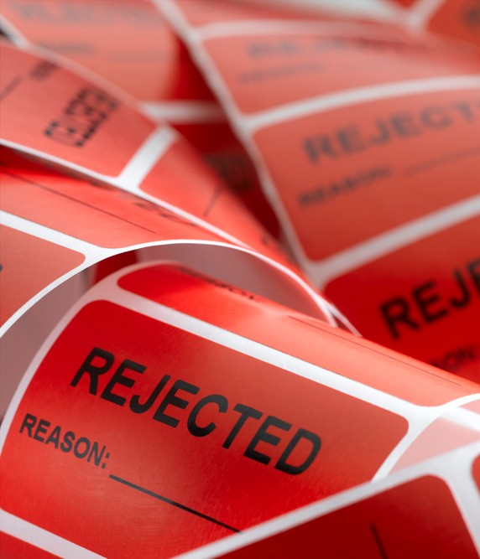
This method can be expensive and inefficient for a business. Rejected products cannot be sold as the manufacturer does not want its name associated with substandard products, therefore these have to be thrown away and this will be a waste of resources and time and will increase costs.

For this reason most modern businesses do not just use quality control they will build-in quality control throughout the
production process. This is called quality assurance or total quality management (TQM) - Quality does not come from inspection but from improvement of the process.

Most manufacturers believe that quality must be ‘built in’. This means that when the finished goods roll off the production line, management is confident that there is no need to check quality.

Inspection is carried out by workers constantly during the production process. The emphasis is placed on preventing the production of poor quality products, as opposed to checking quality at the end of the production line.
Quality assurance has now spread from the manufacturing industry to service industries. For example, in call centres each worker will have a requirement to answer calls in a specific period of time, spend a certain amount of time on each call and achieve a targeted level of sales. Information Technology (IT) allows the performance of each worker to be monitored
and any variation from required standards and targets will be responded to by management. Workers will be retrained to ensure that standards can be met.

Total quality management (TQM) creates quality through continuous improvement, development of systems and products and by creating an organisational culture of quality. The aims of TQM is for zero defects (all products produced are at the required standard) and total customer satisfaction. Using TQM can result in products being cheaper to produce because there is no need to repair or scrap the end product. Also, the quality of the final product results is greater, meaning that consumers of the product will benefit.
For TQM to be effective a number of production management and control methods need to
be used:

- Quality chains are based on cross-functional teams with workers (internal customers). The next person in the production process (chain) is treated as a customer and customer satisfaction is the objective.
- Empowerment – giving workers control over tasks completed.

- Monitoring – checking that standards at each link in the chain are being achieved and the use of statistical tools to measure levels of failure to achieve quality.

- Teamwork – a team approach to product or service improvement. A team is responsible for a production process. The team is empowered to check the quality of raw materials, interact during the installation process and check the quality of the finished product. This implies that responsibility lies within the team. Team work can build trust and morale, whilst improving communication between members. It is regarded as a key element in achieving quality.
- Quality circles – employee involvement in the decision-making and product-
improvement process. Employees meet to identify and solve problems.
- Zero defects – attempting to achieve perfect product quality, time after time.

- Benchmarking – standards based on the best of the competition. If the highest standards are to be achieved, what standards are to be targeted? There is no point in saying that we intend to improve our standard from one fault in 50 to one fault in 100, if our competitors are achieving one fault in 1000. Benchmarking is the process of setting standards of quality and output which are based on the best that competitors can
offer. Benchmarking requires the setting of targets to be achieved in the manufacturing process which matches those of the best competitor. Methods of production need to be designed which ensure that the benchmark levels of productivity and quality are achieved.

Application of recognised standards
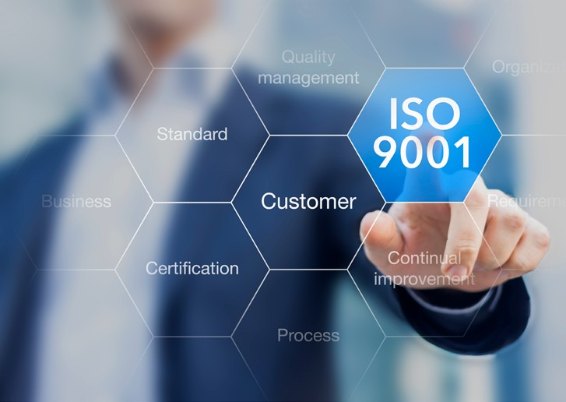
The use of recognised standards such as the ISO 9000 group of standards is widespread amongst businesses. Achievement of these standards by businesses is often an indication of achievement and maintenance of quality.

ISO 9000 is supposed to guarantee quality of management of the whole organisation. Achievement of this standard depends on proving that quality targets for all parts of the organisation have been met.

The importance of quality to a business

- Satisfying customer expectations – businesses want customers to become loyal and come back to the business to make repeat purchases. Customers will expect a certain level of quality when they purchase a product or experience a service, if this quality falls short then there are many other competing businesses that they can switch their loyalty to. Building a good reputation for quality helps with brand loyalty and the purchase of other products produced by the business.

- Increasing customer satisfaction – this is when the quality goes beyond what is expected and gives the customer an excellent experience with the product or service. This is important for new businesses when they are establishing a customer base and are building their reputation. If a customer receives quality that goes beyond what they expect they are more likely to become loyal customers. This may also allow the business to increase prices as customers are looking for excellent value for money.
- Increasing sales – if customers are happy with the product they will become regular customers. If the business develops an excellent reputation in the market then they will attract more customers that will lead to increased sales revenue and hopefully greater profits.

- Reducing costs – an effective quality assurance process will reduce waste, substandard products and customer refunds or replacement products. All these benefits of quality assurance will reduce the costs for the business and allow for greater profit margins.
- Reducing waste – with zero defects there is minimal waste which is not only good for the business by having reduced costs, but also good for the environment and for worker morale.

A business that does not provide products and services at the expected quality will face many
problems:
- Customers will be lost – dissatisfied customers will look elsewhere
- The reputation of the business will suffer – they may develop a reputation for faulty or
poor standard products and services
- Increased costs - in wastage and the recall and replacement of faulty products

- Storage costs – for unwanted products that consumers do not want
- Legal action – if the product causes harm to consumers

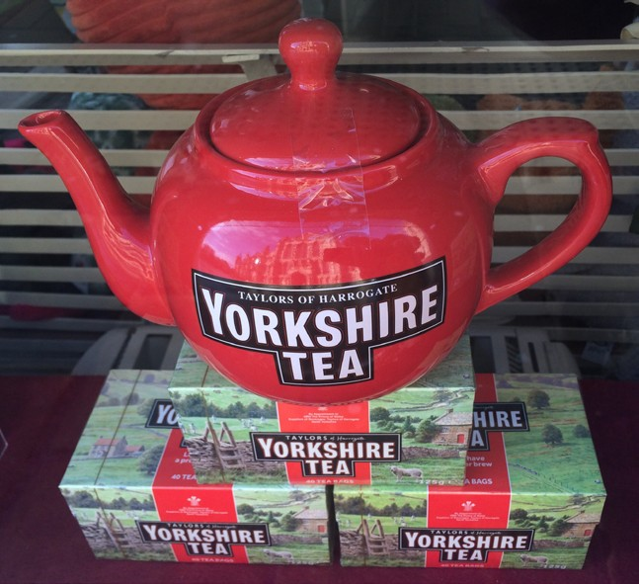Read the following article then answer the questions that follow:

Yorkshire Tea teapots recalled after ‘breakages during brewing’

Teapots and ceramics bearing the Yorkshire Tea logo are being recalled after customers reported they were breaking as they brewed up.
The bases of some one-litre teapots have reportedly fractured and fallen out during normal use, according to Yorkshire Tea. The products have the Harrogate part of the “Taylors of Harrogate” logo written in a lower case font.
Anyone with one of these products is being urged to contact the company.

The products included in the recall are the Yorkshire Tea teapots - one litre and one cup - the Yorkshire Tea Big Tea Mug and the Yorkshire Tea Milk Jug.
Yorkshire Tea, founded in Harrogate in 1886, said the products were sold by Amazon and
independent retailers from 2015.

The company said in a statement: “When teapots from the same batch were tested against the relevant British Safety Standard they did not crack. However, more extensive testing revealed the potential for fracture or breakages during normal use. Therefore, in the interests of our customers’ safety, we’ve taken the decision to implement a recall of all the ceramics made by the same manufacturer.”
Source: http://www.bbc.co.uk/news/uk-england-york-north-yorkshire-39028800
- Why were the products recalled?
- What does this suggest about the quality control procedures?
- What do you think is meant by “the relevant British Safety Standard”?
- What affect is the recall likely to have on the business who made them?

Read the following article then answer the questions that follow:

Faulty tumble dryers: More than 40 000 sign recall petition
More than 40 000 people have signed a parliamentary petition to force Whirlpool to recall three million potentially dangerous tumble dryers. The manufacturer has advised millions of owners to unplug their machines, but has refused to issue a safety recall.
The dryers, sold under the Hotpoint, Creda and Indesit brands, have been blamed for a
number of fires, including one in a London tower block.
Whirlpool has insisted that its offer to repair all the affected machines is the most effective
way to solve the problem.

The dryers subject to the Whirlpool repair programme were manufactured between April 2004 and September 2015 under the Hotpoint, Indesit, Creda, Swan and Proline brands.
Owners have been left wondering what to do about the machines they can no longer use. Many are in the queue to receive a free repair, but waiting lists are said to be up to a year.
Ben Ebdon, who bought a dryer in John Lewis, said he could not get his repaired because the serial number is not being recognised. “I think our dryer may be very dangerous - but Whirlpool say they don’t recognise it, so can’t repair it,” he told the BBC.
Don Kiddle, from Bidford on Avon, said Whirlpool had refused to replace his Indesit dryer until he wrote to his MP.
“I contacted my local MP, Nadhim Zawalhi. He in turn wrote to the chief executive and surprisingly enough we were contacted by the company who delivered a brand new tumble dryer and took the old one away. The item was at zero cost too.”
The Local Government Association (LGA), which represents 48 Fire Brigades in England and Wales, said Whirlpool should begin a “mass publicity” campaign to warn people not to use their dryers.
Whirlpool has written to 3.8 million owners of the affected dryers, offering repairs, but as
many as 2.4 million have not responded.
The LGA repeated warnings that faulty tumble dryers are causing three fires a day, although
not all of these are Whirlpool machines.

“For needless months, consumers have been playing ‘Russian roulette’ with at-risk tumble dryers prone to bursting into flames and destroying homes, and with firefighters attending three fires a day caused by the appliances,” said Cllr Simon Blackburn, chair of the LGA’s safer and stronger communities board.
Source: http://www.bbc.co.uk/news/business-39063180
Write an extended answer to explain the consequences for Whirlpool for selling potentially
dangerous tumble dryers.

1. How could the following businesses measure the quality of their product or service?
- Mobile phone manufacturer
- Hotel chain
- Chocolate manufacturer
- Airline company
- Explain why choosing a reliable and responsible supplier is important for a business.
- Distinguish between quality control and quality assurance.
- Suggest and explain two ways in which a manufacturer of sofas could ensure that it
produced quality products.
- Outline the main features of total quality management (TQM).

- Quality is important for all businesses regardless of the product or price. Do you agree with this statement? Justify your answer.

The supply chain

The supply chain is the various stages of the movement of supplies from their source to the end user. Every business needs supplies in order to carry out their business activity, these supplies can include:
  - Raw materials
  - Component parts
  - Producer goods
  - Equipment for production
  - Incidental supplies used in the running and administration of the business
  - Utilities such as energy and communication
The supply chain could be described as the network of all the individuals, businesses, resources and technology involved in creating and selling of a product, starting with the delivery of the source materials from the supplier to the manufacturer, through to its delivery to the end user.
For each of the products below identify the various participants of the supply chain:
- Free range eggs sold in a supermarket
- Laptop
- Football or fashion magazine

A typical supply chain network:
Supplier
Producer goods
Supplier Electricity
Supplier
Raw materials
Supplier Components
Manufacturer
Supplier Components
Warehouse
Distribution centre
Retailer
End user - customer

The complexity of the supply chain will depend on the type of product being made or service being priced, the scale of the business and the size and reach of the market. For example a

small plumbing business will need a van, materials and equipment for specific jobs and is unlikely to need any large scale storing of these. The plumber will simply buy the materials and equipment from a wholesaler when needed for a job. A mass producer of cars will need thousands of different components which will have to be sourced from hundreds of different suppliers, most probably from all around the world, suitable energy suppliers to power the large manufacturing plants, storage for the finished cars and a complicated distribution network to get the cars to the car retailers who will sell the car to the end user.
The supply chain is also important for the service industry, for example, a hotel chain will need furniture, beds, bed sheets, towels, shampoo, food, drinks, computer equipment, paper, cleaning materials, and so on.
Obtaining the right supplies, at the right price, in the right quantity and of the right quality
is a major business activity, many medium sized and large business will have a supply chain management function in order to make sure this is organised effectively and meets the needs of the business.
The supply chain can be divided into 3 clear stages:
  - Procurement
  - Logistics
  - Stock control

Procurement
This is the purchasing of raw materials, goods and services for a business. A business needs to identify suitable suppliers who will provide the goods and services needed for the business to carry out its activities. When procuring supplies, a business needs to consider:
  - The cost
  - The quality
  - The delivery time
  - Reliability of the supplier
  - Reputation of the supplier
  - Ethical and environmental actions of the supplier
  - Payment terms and contractual issues (late or non-delivery of stock penalties)

The best supplier is not always the cheapest, consider what could happen to a manufacturer of electric ovens who bought the glass for the oven door from a supplier that was the cheapest but the glass was not tough enough to keep in the heat when the oven was used at high temperatures. Or a 5 star hotel buying washing detergent that was the cheapest but resulted in laundry not being cleaned properly.
Some suppliers may be able to supply good quality products at a reasonable price, but only

in small quantities, this would be no good for a large manufacturer who wanted the same quality for all the products they produce. Businesses will also require the supplies at the time they need them, not receiving supplies in the production process at the right time can hold up production and increase costs for a business. The supplier must also be reliable and be able to deliver the same quality of product on time every time the business needs their supplies.
Many businesses in the modern business environment have strong ethical and environmental beliefs and objectives. A business cannot be truly ethical if it uses a supplier that pays below the minimum wage, employs children, has poor working conditions or engages in any other unethical practices.
As cost is a major factor for most businesses, the business will seek to delay payment of the supplies as long as possible, some suppliers will offer very good payment terms to attract businesses. However, if the purchasing business is in a strong position they may insist on very favourable payment terms for themselves at the expense of the supplier and put the supplier in a difficult financial position.
When procuring supplies a business needs to take all these factors into consideration and
make a choice that fits their business.

Ethical sourcing involves products being sourced in a responsible and sustainable way.
Environmental and social impacts are considered and the workers involved in making them
are safe and treated fairly.
Many businesses will make a commitment to carry out ethical sourcing. However, they must balance this commitment with the need to keep costs down in order to compete in a competitive environment.

An example of this ethical commitment is shown below for the John Lewis Partnership:

JOHN LEWIS PARTNERSHIP RESPONSIBLE SOURCING CODE OF PRACTICE

Introduction
The partnerships we have with our suppliers help us to offer our customers over 350 000 product lines in John Lewis, from fashion and furnishings to household goods, and around 18 000 high quality food products in Waitrose.

In sourcing these products from many different countries, we aim to uphold internationally agreed standards of labour, and we expect our suppliers to treat workers fairly, honestly and with respect for their basic human rights and well-being.
Our aim is to build lasting relationships with suppliers and we have always recognised that our responsibility extends to their employees and suppliers. As a result, we have worked with our suppliers for many years to help them build sustainable businesses, commercially, ethically and environmentally, and to provide long-term, satisfying employment.

Robust policies and procedures and strong relationships with our suppliers are essential if we are to continue to source our products responsibly. Our Responsible Sourcing Code of Practice sets out the Partnership’s expectations of suppliers on issues such as pay, working hours, child labour, worker rights and representation.
In building long term relationships with our suppliers, we seek to work with companies who share our values and who are prepared to commit themselves to meeting the requirements of this Code. We are committed to working with suppliers to support necessary improvements but we may also take action if suppliers are not prepared to work collaboratively to drive improvements.
We believe that the application of our Code enables real and practical steps to be taken towards improving social conditions in those locations involved in the production of the goods we sell.

Charlie Mayfield
Chairman, John Lewis Partnership

Source: http://www.rspo.org/file/acop/waitrose-ltd/R-Policies-to-PNC-ethicalconducthr.pdf

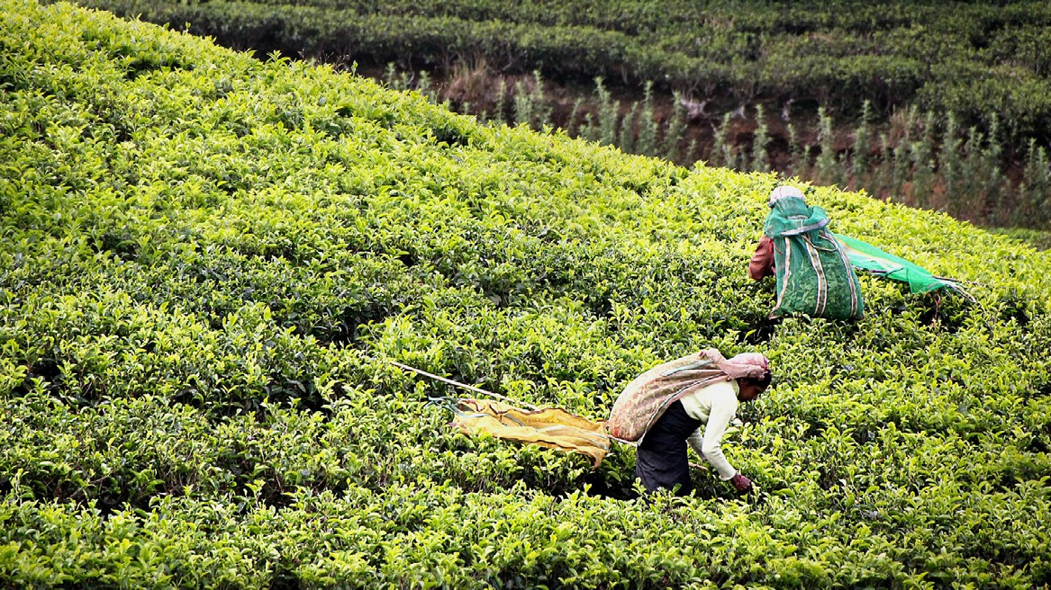
Read the article and answer the questions that follow:

UK tea brands drop Indian supplier over work conditions

Three of the UK’s top tea brands have stopped buying from a group of Indian plantations
after a BBC investigation exposed dangerous working conditions.

The BBC found a disregard for health and safety on an estate in north-east India owned by Assam Company. The Rainforest Alliance, an ethical certification organisation, has now stripped a group of Assam Company’s plantations of its green frog seal.

The Assam Company said it was appealing against the decision. A group of Assam Company’s estates lost its certification because “it was found to be in breach of critical criteria relating to the use of personal protective equipment”, the Rainforest Alliance said in a statement.

The Assam Company said the loss of its certification was because of a “minor error” on one estate - Hajua - while spraying a plant extract, which is understood, did not require personal protective equipment. It said that because the Assam company estates operate in a “single cluster”, the other estates were automatically decertified.
Twinings, Taylors of Harrogate and Fortnum & Mason have suspended business with the
company while Harrods took the tea off its shelves shortly after.

Workers at the company’s Hajua estate were seen spraying agrochemicals without the protective equipment employers are required to provide, when the BBC visited.
Men spraying reported breathing difficulties, numbness of the hands and face, a burning
sensation on the skin and profound loss of appetite.
Taylors of Harrogate said it will maintain a relationship with the estates and support efforts
to improve standards.

Twinings plans to continue working with the Ethical Tea Partnership (ETP) - an organisation set up by UK tea companies to improve workers’ lives - to monitor the working and living conditions on all the tea estates from which it buys. It also plans to conduct a review of the Assam estates it sources from in the next few months.
Fortnum & Mason says it will not buy from Assam Company until its “problems have been
successfully resolved and they are once again Ethical Tea Partnership certified”.

The original investigation also found workers on a number of Assam estates and plantations belonging to other producers living in broken houses with terrible sanitation.
The Rainforest Alliance has ordered improvements to living conditions on two other plantations, owned by the world’s biggest tea producer, McLeod Russel. The Moran and Behora tea estates supply the companies that own PG Tips and Tetley, as well as Twinings.

Unilever, which makes PG Tips, told the BBC it welcomes the fact that improvements on areas like housing and health and safety are being accelerated and will be subject to additional monitoring.
Tata, which makes Tetley, said it has met with the producers to understand their plans to address the issues the BBC uncovered. It has been in discussion with the Rainforest Alliance and says it is committed to the fair and ethical treatment of people across its supply chain.
Adapted source: http://www.bbc.co.uk/news/business-35235293

- With reference to the data, explain how companies such as Twinings, Taylors of
Harrogate and Fortnum & Mason are committed to ethical sourcing.
- Explain why these companies have stopped buying from the group of Indian plantations.

- Do you think that the demand for tea from India will drop as a result of this investigation? Justify your answer.

Jill Francis runs a café in the centre of Bath, she sells mainly locally produced products, most of which are organic and she uses this in her image for the café and in her advertising. She can’t source all her products locally so she buys some products, such as cooking oil, soft drinks, pasta and pre-packed snacks from other suppliers. Her customers are prepared to pay a higher price for quality food, though Jill sometimes fails to make a profit during some weeks.

- Explain what is meant by sourcing products locally.
- Why will this give the café an ethical/sustainable image?
- Why is selecting the right suppliers important for Jill?
- With reference to procurement, explain why Jill sometimes fails to make a profit.

Logistics
Logistics is the management of the flow of products, services, equipment, people, money and information from the source to the end user. Logistics management is concerned about getting everything in the right place for when it is needed. Logistics includes:
- Transportation of supplies
- Storage (warehousing) of supplies
- Storage (warehousing) of finished products
- Inventory of supplies and finished goods
- Packaging of finished goods
- Transportation and distribution of finished products
- Organisation of individuals working in logistics
- Security of supplies and finished goods

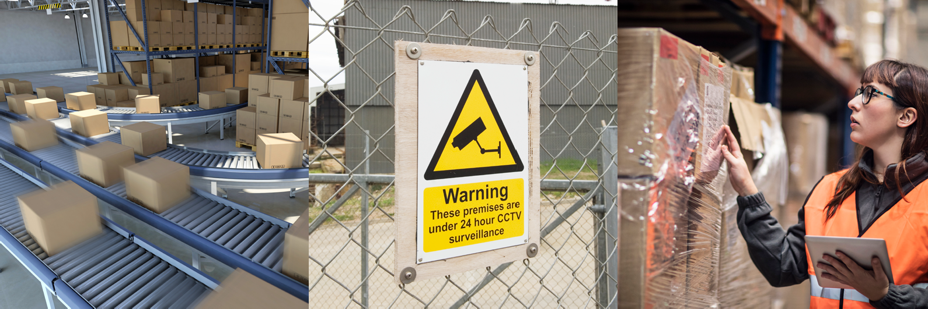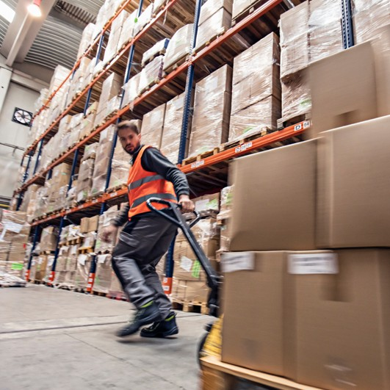

Use these images to outline the main aspects of logistics.

For small scale businesses, such as independent retailers, logistics is straightforward; the supplies are delivered by suppliers or picked up from a wholesaler and then stored in the shop, either on display or in a stock room, and the customers will visit the shop to buy the products. For large scale businesses, particularly manufacturers who use mass production to produce thousands of products, logistical decisions and organisation are more complicated and will have fulltime workers constantly ensuring the right supplies are procured, delivered and used to produce quality products for customers.
Logistics flow chart:
Suppliers
Inbound logistics from suppliers
The movement of goods and raw materials from the supplier to the business
Use of suitable transportation
Production and warehousing
Goods and raw materials are stored/used in the production process and then ﬁnished products are stored/made ready for distribution
Use of businesses production and storage facility

Raw materials and products are transported by:
Outbound logistics to customers
Finished products are distributed to customers
Use of suitable transportation
Customers
- Sea
- Air
- Rail
- Road

In a global business environment where businesses will source and sell products all around the world a business may use a combination of transport methods to transport goods. Goods that are transported in bulk are also called freight or cargo. A business can use its own fleet of vehicles or pay for external couriers to deliver materials and to distribute to customers.

Consider the logistical processes carried out to get a toy robot from the initial design to the consumer.
Make a list of all the logistical stages you think are involved.

The growth of globalisation has resulted in many UK businesses sourcing their raw materials and other supplies from all around the world. For some products, with many components, the final combined total of miles travelled will be in the thousands. This has caused concern amongst people who are concerned about carbon footprints and food miles.
Food miles are the distance a certain food has to travel from its point of origin to its point of destination - the consumer.
The following information is from http://www.pollutionissues.co.uk and explains the
concern of sourcing food from around the globe:

Remember the days when the first strawberries of the year were the ones shown on television at Wimbledon? How times have changed, for now all kinds of exotic fruits and foodstuffs are available the year round at our local supermarket – flown perhaps thousands of miles around the world so that we can have blueberries for breakfast in winter if we wish.
But what is the environmental impact of these so called ‘food miles’ and how does it affect
us?

Food Mile Facts
- 95% of our fruit comes from abroad.
- Half of our vegetables are imported.
- 30% of all goods transported by lorry around the UK are foodstuffs.
- Food imports increased from 13.5m tonnes in 1992 to just over 16m tonnes by 2002
.
- Whilst only 1% of food is transported by air, it accounts for 11% of carbon emissions.

- A rainforest the size of ten football pitches is felled every second, some of which to make room for exported food crops.
- Since 1992, the amount of food flown by ‘plane has risen by 140%.

Air Freight
The least environmentally friendly way to import and export food is by air and yet is the most quickly expanding method of transporting food.
Due to the huge amount of greenhouse gasses given off by aircraft, two main supermarkets have labelled food imported in this way with dedicated labels, to give customers the chance to make an informed choice about the food they buy.
However, the arguments have become complex with time, and there is much more to consider than solely the CO2 emission factor. One million African workers now depend on fruit and vegetables specifically grown for the UK market and without this they would struggle to survive.

Lorry Loads of Food
The most common form of transporting food once it’s reached the country of destination is by lorry. 25% of all journeys made in the UK will be taking food from destination to

destination until it’s stacked on a supermarket shelf near you. These journeys account for 25% of CO2 emissions.
It has been stated that if we all endeavoured to buy food originating from within a 20km radius from our locality, the country would save over two billion pounds in congestion and environmental costs.

What Can We Do?
There are several simple steps we can take to help reduce the environmental impact of food miles on the environment:
- Shop locally and if possible, leave the car at home.
- Plan one big trip if using a large supermarket instead of going two or more times per week.
- Buy fair-trade goods which support third world communities and are usually transported by sea.
- Buy fresh seasonal produce grown locally.
- Buy food with as little packaging as possible.
- Buy organic produce.

Source: http://www.pollutionissues.co.uk/food-miles-environmental-impact-food.html

Use the food miles calculator on http://www.foodmiles.com/results.cfm to see where your food comes from and how many miles it travelled.

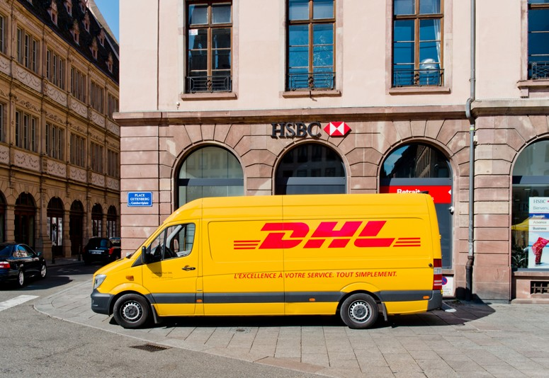
The growth of e-commerce and online shopping has changed the way many businesses organise their logistics. The growth of businesses such as online retailers Amazon, Ocado, ASOS and AO, eBay and the thousands
of smaller online retailers, together with the expansion of online sales from supermarkets and other high street stores have resulted in a huge expansion of couriers and parcel delivery businesses.
Businesses such as DPD, Parcelforce, Hermes, DHL, FedEx
and UPS play an important role in the logistical stage of the supply chain.

Read the following information and answer the questions that follow:

Amazon UK Fulfilment Centres

Amazon has been one of Britain’s largest and fastest growing businesses for 20 years. Amazon.co.uk is the country’s 5th most visited website and the number one place for shopping.
All these website visits and sales inevitably lead to a wave of activity in Amazon fulfilment centres, of which there will be 16 in the UK by 2017. This network of regional warehouses covers the whole of the UK and ensures all orders arrive with the customer in good time. For suppliers, this means lots of stock needs to get to and from those fulfilment centres, which are otherwise known as distribution centres. These are huge warehouses where the products on sale are stored and dispatched all over the UK. Swansea Bay caters for Wales and the West, in the South of England is Hemel Hempstead and Dunstable, then in the rest of England there’s Milton Keynes, Peterborough, Rugely, Manchester, Leicester and two in Doncaster. In Scotland the Dunfermline and Gourock sites make up the UK map of Amazon locations so far. Planned for 2017 are centres in Daventry, Coventry, Tilbury (Essex) and a third Doncaster depot.

Every item that is dispatched by Amazon, including the marketplace sellers that choose to deliver in batches to be Fulfilled by Amazon (FBA) passes through one of these
hubs. Distributors and suppliers all over the UK need to get their goods into the designated fulfilment centre on time.
These fulfilment centres are huge and employ thousands of workers.
Source: http://www.thenxgroup.com/2016/12/12/amazon-uk-distribution-centres/

- What is a fulfilment centre?
- Explain how the location and scale of the fulfilment centres is important in getting
products delivered to customers within 24 hours of being ordered online.
- How important is logistics planning to a company like Amazon?

Stock control
Effective stock management, whether it is of raw materials, work in progress or of finished
goods, is an important part of the supply chain and operations management.
Key aspects of effective stock management:

- Businesses must ensure that stock is available for use within the manufacturing process as and when it is needed.
- Part-finished goods (work in progress) do not sit around the factory floor unused and losing value: instead they are brought to the next stage as soon as possible.
- Finished goods are available for timely delivery to customers and are not made before customers are found for them.

Traditionally, the main method of ensuring a ready supply of raw materials has been the maintenance of large buffer stocks. These are relatively large stock holdings held just-in-case (JIC) they might be needed.
This method of stock management made sure that sufficient stock was always available.
However a just-in-case approach has disadvantages:
- Money spent on stock is used up and not being put to better use elsewhere
- Large quantities of stock have to be stored (securely) and this costs money in warehouse costs
- Stock can be damaged or stolen

- Certain types of stock, such as food and other perishable products, has a short life span and will need careful monitoring and possibly be disposed of if there is a drop in demand for the finished product.

For these reasons many businesses today have reduced their stock holdings. The old idea of buffer stocks has been largely abandoned in favour of the effective use of just-in-time (JIT) systems.

JIT is designed to minimise the costs of holding stocks of raw materials, components, work in progress and finished goods. This is achieved by carefully planned scheduling in order that resources can flow through the production process smoothly.
There are a number of key requirements for JIT to operate effectively:
- a very efficient ordering system

- suppliers that reliably deliver raw materials and components just when they are required
- a well-trained workforce which can be trusted and who are willing to work in teams

Under a JIT system materials are delivered shortly before they are required by the manufacturer and go straight onto the production line – virtually no stock is stored on site. Products are not made unless an order has already been placed, and when the goods are complete they leave the factory to be delivered to the customer. Operating a JIT system reduces stockholding costs, so money can be used elsewhere, reduced warehousing space is needed, again reducing costs and reduces waste and theft.
The operation of a JIT system is not without its problems. Ordering, administration and transportation costs are likely to rise and the advantages of bulk buying may be lost.
Suppliers who do not deliver on time can bring the whole production line to a halt, leading to a manufacturer’s reputation being damaged if customers do not receive their goods on time. There is little room for mistakes as stock levels are so low and there are no spare finished products available to meet unexpected demand.

Computerised stock control
Businesses today hold their stock details on computer databases. This improves efficiency and accuracy. When the quantity of stock decreases or increases, the database is updated instantly which allows for accurate stock checks and the automatic reordering of stock if the level falls below the reorder level (the level of stock at which a new order is placed).
Businesses can monitor what has been used and the frequency of use, many computerised stock control systems will even order the stock automatically.
The best example of this is the stock control systems used by the main supermarkets. The system is connected via computers to the checkout tills, and when products are scanned in the stock control database is automatically updated.
- Why is stock control an important part of the supply chain?
- Why is holding too much stock inefficient?
- What are the dangers of holding too little stock?
- Explain what is meant by JIC and JIT.
- How are computers used to improve the efficiency of stock control?

Relationship between the supply chain and other functional areas of a business
The way in which a business organises its supply chain will depend on the aims and objectives of the business. The decisions made in procurement, logistics and stock control will not be made in isolation – supply chain management will work with marketing, sales, finance and human resources in order to achieve the common objectives of the business.

Marketing may carry out market research that shows that consumers are not happy with the quality of the products and as a result the business may look to improve the quality of their supplies. However this may increase costs and the finance department will get involved to see if the business can afford this. It could result in increasing prices, the sales team will
need to be informed and price lists adjusted. Perhaps new equipment could be purchased to improve quality, the human resource department will get involved to train workers to use the new machinery or carry out more general training to improve the skills of the workforce.

The business may decide to change from a JIC stock control system to JIT. As well as communicating this to suppliers, the sales team will need to know if this will affect delivery times to customers. The marketing team may decide to carry out some new advertising and promotional activities; are there enough finished goods in stock to supply the expected increase in demand as a result? Will workers have to work over-time to produce enough stock? The payroll team in finance will have to be informed.

1. Explain how the following decisions may affect the supply chain:
- The business decides to reduce costs across the business by 5%
- The directors of the company wish to become a more ethical and sustainable business
- The reputation of the business has suffered with a high number of products being
recalled.
2. Explain how the following activities in the supply chain will affect the whole business:
- A supplier fails to meet deadlines for a large order
- A burglary at the warehouse results in many finished products being stolen
- A major supplier becomes bankrupt
- Workers in the factory go on strike
- Poor weather reduces the supply of raspberries needed for the production of jam.

The impact of supply and logistical decisions on a business and its stakeholders
When making decisions on:
- where to source supplies;
- what quality and price to pay;
- how to manage stock;
- how to transport and distribute finished products;

a business needs to consider the impact of the decision on the business and its stakeholders. These include:

- Costs to the business - the business needs to make a profit for the owner or shareholders. An effective supply chain can reduce costs and make the business more competitive. The cheapest supplier does not always result in the cheapest final costs if the finished product is defective or if consumers stop buying it. Choosing a supplier the other side of the globe may result in cheaper unit costs, but transport costs may be very high.
- Quality of finished goods – customers will require value for money, ultimately the quality of the finished product will be the main reason why customers spend, or don’t spend, their money. The suppliers chosen by the business must be able to consistently supply the materials at the expected quality. Substandard material will produce substandard finished goods.

- Reliability of delivery – supplies have to be in place at the right time. Products must be available in the location that customers expect. How much risk is involved in selecting suppliers that require complex logistics? The longer the chain the more chance that something will go wrong.
- Production process – supplies have to be suitable and reliable for production. Production workers have to be able to work with the materials and the material must be suitable to use with equipment.

- Price – does the cost of supplies allow finished products to be sold at competitive prices and will a change in supplier affect the price? The raw materials and components selected for production must take into account the market price for the type and quality of product being made. It is no good producing a high quality product if it is sold at a loss.
- Customer satisfaction – are products made to the required standards and are they available when the customer wants them? An effective supply chain is likely to lead to customers that are satisfied with the quality of the product or service they receive. The global business environment means that buyers have more options to order products than ever before, businesses have to adapt their supply chains to meet customers’ preferences.

- Reputation – poor quality or unreliable products will not develop customer loyalty. A disruption in the supply chain or the need to make product recalls can lead to a fall in reputation. Having a good reputation for quality and reliability will give the business a competitive advantage.
- Sales and profits – ultimately a key objective for most businesses is to achieve regular

sales that will grow over time in order to create a good profit margin for the business.
Any supply and logistical decisions must always be based on the core business objective.
Consider the main supply and logistical decisions that have to be made by the following businesses:
- A sole trader making cakes that are sold to local cafes and shops.
- A multinational fast food chain looking for supplies of eggs to use in its UK outlets.
- A manufacturer of high quality sunglasses sold via their own website.
- A national chain of “discount shops” looking to stock 150 shops around the UK.
- An entrepreneur wishes to start a new business producing scented candles.

The sales process

How a business organises it sales function is very important. Without sales a business will not succeed. The sales process is how the business interacts with its customers and receives revenue.

Businesses of all sizes and operating in different markets will want to make as many sales as possible. The sales process is a series of steps that helps businesses make sure they maximise sales to potential customers and encourage customers to return to the business to make repeat purchases.
The precise sales process a business uses will differ depending on:
• The product - is technical knowledge of the product required by the customer?
• The market – what is the expectation of the customer and the normal ways sales are
conducted?
• The price – low value or high value
• The customer – consumer or business
• The place – how the product is sold, face-to-face, online, telephone, etc.
• The quantity – the number being bought

Describe how a business is likely to interact with customers in the following sales situations:
- Buying a chocolate bar in a shop
- Buying a holiday from a travel agent outlet
- Buying a holiday from a travel agents website
- Buying a new car from a car dealership
- Buying double glazing for windows from a sales representative visiting the customer in
their home
- A farmer buying feed for his/her pigs

Carrying out a successful sales process will increase the chance of making a sale. The process will also allow businesses to build good customer relations and receive regular and returning customers. In contrast a poor sales process is likely to result in losing customers, increasing customer complaints and a fall in sales revenue.
The sales process is important to retain existing customers and also to grow the business and
attract new customers.

Stages of the sales process:
Identifying sales opportunities
Understanding needs and wants of customers
Informing customers of the features and
beneﬁts of the product or service
Customer engagement
Closing the sale
Following up and after sales
Preparing through good product knowledge
{

Preparing through good product knowledge – a salesperson should know the details of the product or service they are selling. For some products technical details are very important and the salesperson will need this knowledge in order to answer customer queries and
to explain the features of the product. Customers will expect salespeople to have good
knowledge of a product, especially when there is a range of products on sale.
Consider the product knowledge needed by salespeople for the following products and services:
- Laptops
- Car insurance
- Mobile phones
- Prescription glasses
- Gas and electricity supply

Identifying sales opportunities – a salesperson will need to identify possible customers and then identify what the customers want. Not all businesses will have customers walking into their outlet looking for sales; some businesses will have to actively look for customers, and this can be done by telephone, email or face-to-face. When looking for these sales opportunities a business may need to carry out some research on potential customers to see if they will become potential customers.
When the salesperson has good product knowledge this stage should be straightforward; by asking questions the salespersons can identify if the potential customer can benefit from the service or product offered.

Understanding needs and wants of customers – when approaching a customer or being asked for help, a salesperson should ask questions to identify what the customer needs or what they want. The salesperson should then be able to match the product or service on sale to these needs and wants. A good salesperson will listen carefully and be honest in what they recommend to the customer – after all if the product or service is not matched to the requirements of the customer it is likely to end in a dissatisfied customer who will either return the product or go elsewhere for their next purchase.
You work as a salesperson in one of the following businesses. Select one then write a list of the questions you need to ask the customer in order to understand their needs and wants:
- A florist
- Mobile phone retailer
- Car dealership
- Sofa retailer
- Travel agents
- Online bank offering personal loans

Informing customers of the features and benefits of the product or service - this stage should focus on the benefits for the customer by explaining the product/service features and the advantages and benefits of buying a particular product or service. For most products there are a range of alternatives that they could buy, for example, buying a computer presents the customer with many options, and this can be confusing, especially when there is technical information to consider. If possible, the salesperson could demonstrate the product at this stage to show how the product performs.
The salesperson may also need to respond to the doubts and questions that the customer may have and deal with any objections to buying the product. Once again it is important to be honest and not tell lies just to sell the product.
At this stage many businesses may try to “up sell”. This is when the salesperson will identify an opportunity to sell a more expensive model of the product or service or, introduce related products or services in order to increase the value of the sale. Examples include introducing customers to a more expensive model with additional features and a sales pitch that explains the benefits of the upgraded model. Other examples of upselling include selling warranties for electronic products, internet security products when buying a laptop, protective wax finish on cars, pushing sale products at checkouts in shops and “do you want to go large on that burger” at fast food outlets.
Closing the sale – this is the main purpose (from the businesses point of view) of selling. It involves the customer agreeing to pay for the product and having the money to do so.
For most businesses this will be a cash or debit card purchase, but can also include a credit card purchase or a credit agreement with the business (for example, paying in monthly instalments).

A salesperson can encourage a customer to close the deal by offering a special benefit on top of what the product or service offers. This is useful when the customer is still unsure about making the purchase, examples of this include:
“If you buy today I will give you a 10% discount” “This is the last one we have in stock at this price”
“If you buy today, I will give you one extra year's warranty for free”

There are many different approaches and styles for salespeople to close the sale, and the approach taken will depend on the type of product or service being sold, the price of the product or service and the nature of the sales environment; such as face-to-face, on the telephone, or on the internet.

Visit http://www.wikihow.com/Close-a-Sale and read through the “How to close a sale” presentation. Then answer the following questions:
- What is meant by “smile with your eyes”?
- What is meant by “qualifying a customer so that you sell them what they need”?
- Buying signals can be both verbal and non-verbal. What does this mean?
- What are a direct close and an indirect close of sale?
- What is the “balance sheet” close of sale?
- What is the “puppy dog” close of sale?
- What is the “assumptive” close of sale?
- How can the salesperson use emotions to close the sale?
- Why should upselling not always be attempted?

Source: http://www.wikihow.com/Close-a-Sale#/Image:Close-a-sale-Step-2-Version-3.jpg

Following up and after sales - the sale does not complete the selling process. A business should conduct follow-up activities which can be important and valuable for the future success of the business. After sales service can include a variety of activities to find out whether the customer is happy or unhappy with their purchase. Depending on the product or service being sold, a business should check, for example, if the products have been received in good condition, or the customer received good service, in order to find out if the customer is satisfied with their purchase. This can be a good way to measure the quality of the product or the service they provide.
After sales can also include the service customers receive on complaints, faulty goods, maintenance or repair and support.
After sales service can play an important role in customer satisfaction and customer retention as it helps to create loyal customers. A satisfied and happy customer can spread their positive experience with other individuals which could result in attracting new customers to the business.
Many businesses will contact a customer a few days after the purchase for feedback; this can be by telephone or email. A business should use this feedback to improve their product or service as it can provide useful information that might help the business to increase sales.
Effective after sales techniques include:
- Stay in touch with the customers
- Give customers the necessary support. If required help them install, maintain or operate a particular product.
- Exchange any broken or faulty product immediately.

- The business should have a clear exchange policy in favour of the customer. The customer who comes for an exchange should be given the same treatment as given to them when they made the initial sale.
- If the business has a website, create a section to allow customers to register and describe their complaint. The business should take a prompt action on the customer’s queries.
- Encourage feedback of the products and services from customers. Feedback helps the business to know the customers better and carry out the necessary changes for better customer satisfaction.

Read the following information on Audi’s after sale service for business customers then answer the questions that follow:

Audi Business Aftersales: supporting you and your fleet
At Audi we believe you should expect excellent service every time you make contact with us.
We train every member of our team to deliver the highest standards of customer service. We want to make sure that you enjoy a consistent, helpful and stress-free experience whenever you’re in contact with us.
Find out about Audi Aftersales services below:
- Audi genuine parts - We only use genuine parts and accessories and each one comes
with a two-year warranty, excluding wear and tear items.

- 70 000 hours of technical training - We invest in over 70,000 hours of technical training each year, giving our Audi trained technicians unrivalled skills and know-how.
- Diagnostic investigation - If you have an issue that isn’t covered by your warranty, we’ll
carry out an initial diagnostic investigation for a fixed fee agreed beforehand.

- Courtesy car - We’ll give you an Audi courtesy car while yours is with us. Or, if it’s more convenient, we can collect and deliver your car.
- Wash and vacuum - We’ll wash, clean and vacuum your Audi after we’ve worked on it, with our compliments.
- Phone confirmation - Before you visit, we’ll call you to confirm the work we’ll do and
discuss any special requirements you may have.

- All-inclusive quotes - We’ll give you an accurate quote, every time, without hidden charges.

- Service price match - Get a quote from any provider for a service, repairs, maintenance or new tyres. If it includes Audi genuine parts, we guarantee you won’t pay a penny more for the same job at Audi.
- Online booking - Our online booking service makes it quick and easy to book your service, at a time that works best for you. Visit the Audi Online Service Booking Tool.

- Audi cam - If an Audi trained technician discovers an issue, they can show you with an Audi Cam video sent to your device. So wherever you happen to be, you can see exactly what needs doing.

- One-stop shop - From fixed-price servicing and repairs to MOT and tyre replacement, you’ll find everything your Audi needs at your Audi Centre.
Source: https://www.audi.co.uk/business-and-fleet/business-aftersales.html

- Give examples of Audi’s business customers.
- Summarise the main after sales service Audi carries out.
- Explain the importance to Audi of offering these services.

Customer engagement – takes place throughout the sales process and is the communication that takes place between the customer and the business during the selling of products and services. A business will want to engage the customer in a positive way
throughout the process in order to create loyal customers and repeat purchases. This applies to face-to-face and internet sales – on completion of the sales the customer should have positive thoughts of the process and confidence in the business they have spent their money with.

The customer engagement should result in a positive and continuous relationship with the customer, it is important that all stages in the sales process maintain this positive relationship in order to fulfil and go beyond the expectations of the customer.

Adapting the sales process

Although the sales process should be used in all sales transactions they will differ in different situations. For low value products such as bread, fish and chips and toilet paper, the process will be straight forward and the customer will not expect the engagement to be lengthy or
all-inclusive. However, for high value products and services, such as, diamond rings, cars, holidays, houses, expensive furniture, etc., the customer will have higher expectations of the sales service they receive. For high value goods, it is likely that a customer will choose businesses that not only provide quality products and services, but also give the customer an excellent and complete engagement in the selling of those products and services. They
will expect a more personal service from the business, more time and attention to detail and
possibly the premises to be more prestigious and remarkable.

In the UK the sales service provided by many retail businesses is often criticised for being poor and not offered to a high standard. Many retailers will employ young inexperienced workers who receive minimal training on how to deal with customers.

Watch an episode of Mary Portas Secret Shopper: http://www.channel4.com/programmes/mary-portas-secret-shopper/episode-guide/ series-1.
Then answer the following questions:

- Summarise the issues she has discovered with the retailers.

- What solutions did she suggest to solve them?

- How will these solutions improve the customer engagement with the business?

The number of businesses selling online has increased enormously in recent years. This is now a very competitive sales method and it is important that the customer engagement is as effective online as it is face- to-face. Online retailers will invest large amounts of money into website design and maintenance to make sure they offer customers a positive buying experience.

Using a website that you are familiar with or have bought from, explain how the business:
- Provides good product knowledge
- Understands the needs and wants of customers
- Inform customers of the features and benefits of the product or service
- Close the sale
- Follow up and after sales
- Engages with the customer and gives a positive experience.

Relationship between sales and other business functions
The sales process is the end result of all the hard work put into the business from the start. In order to carry out sales effectively the sales process and the sales team will work with the other functions of a business.
Production – without a quality product or service the sales team will have nothing to sell. The procurement of suitable raw materials and components are needed to make a product that will appeal to customers. The management of the production process will make sure a product is produced at a cost that will allow a competitive price to be charged, make sure the
product is where it needs to be, so there are no delays in getting the product to the customer,
and deal with any customer requirements, such as different colours, sizes and individual

modifications. If the sales team are experiencing high sales for one product then this should be communicated to the production team to make sure that resources are transferred to make sure the supply of products in demand are being produced to the required levels (stock control). If the product is delivered to the customer from the distribution centre, such as a car or large electrical appliances, the sales team will need to confirm with the logistical team to find out delivery dates for the customer. Feedback received from customers can also be passed on to the production team to take any action that might be needed to boost sales.
Marketing – the range of products offered, the price they are sold at, the places where they
are sold and the way in which they are promoted are all tasks carried out by marketing.
Changes in the marketing strategy, such as an increase in price or an expansion of
the product range, will impact on the sales process. The sales team will need accurate information on prices, any sales promotion and product information to make sure they give correct and up-to-date information to customers. Any details of future promotions that hope to sell high volumes of a particular product or service should be communicated to the sales team so that they can prepare their product knowledge in order to push these sales with customers. The sales team can also give the marketing team feedback from customers which can be used in carrying out market research.
Human resources – new and existing employees may need to improve their skills and
product knowledge and this training will be organised by the human resource team. Appraisal and employee reward schemes, which are popular in retail, are carried out to monitor employee performance and reward good performance. The sales management will work with human resource management to identify any recruitment needs in order to deal with an increased volume of customers, this can be permanently or in times of peak sales, such as Christmas or summer time.

Finance – the sales process is the money generator of the business; all the money coming in through the sales revenue will be monitored and recorded by the finance team. The finance team will set targets for sales over a period of time, and could also be involved in setting individual sales targets for individual sales people. The finance team will also determine the amount of commission that can be paid to sales people for every product that is sold. For some businesses the price of the product is flexible and the sales people can negotiate with customers over price, the finance department is likely to have the final say on this, as they will know what price will lead to a suitable profit being made on the sale of the product. If the sales team fail to maintain good customer relations and as a result sales drop then this will have a massive impact on all the other functions and the business as a whole.
The sales process must work with all the functions of the business to make sure the overall aims and objectives of the business are achieved.

- Explain the importance of an effective sales process to a business.
- Identify the key stages of the sales process.
- Explain how the sales process is adapted for telephone and online sales.
- Carry out a role play for selling one of the products listed below. In preparation learn the
product details that allow you to give the customer a positive experience:
  - Tent
  - Fitbit
  - Electric shaver
  - iPod
  - Home cinema and sound bar

Customer service

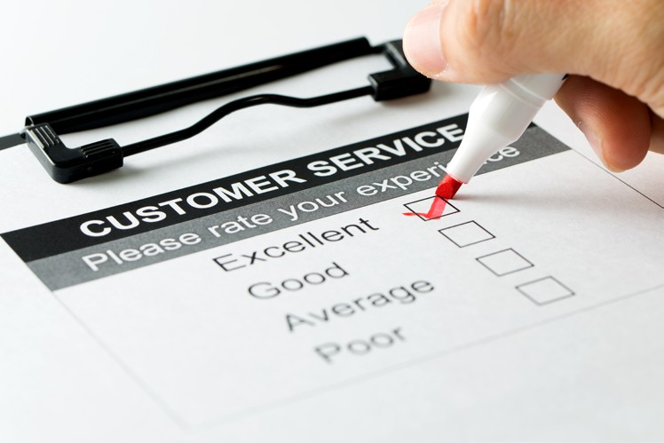
Customer service is the support that a business gives to its customers. This takes place before, during and after a customer has bought the product or service. In a competitive market customer service is important to all businesses. Good customer service can result in
customer loyalty and ensuring customers return to the business time and time again to make repeat purchases. Poor customer service can result in losing customers and gaining a poor reputation in the marketplace.

It is much cheaper and profitable to keep existing customers rather than to keep looking for new ones. Having a quality product with good customer service will help to retain customers and also help in attracting new ones. Retained and happy customers are more likely to increase the money they spend over a period of time and therefore add to the revenue of the business.

Customer service is important in the sales process, but beyond that, it involves all contact and communication a business has with potential and existing customers. Customers expect a certain level of customer care from a business; this includes a number of different aspects of what a business provides:
  - The product or service – quality and reliability is important

  - Information (queries) about the product or service - this must be correct, up-to-date and clear
  - The sales process – including all the stages
  - Dealing with complaints
  - Delivery and/or installation

  - Any communication with employees that takes place before, during and after the sale

  - The place where the product or service is purchased – including premises, access to the premises, parking facilities, opening times, access for disabled customers, website navigation, ease and variety of paying, clear contact procedures

Good customer service will therefore encompass the whole business and this culture will help the business to maximise sales and profitability. It is believed by many successful businesses that customer service needs to go beyond the expectations of the customer in order to develop the business and give it an excellent reputation.
Good customer service will result in:
  - Increased customer loyalty
  - Increased customer spend
  - A good reputation
  - Attract new customers

These should then lead to increased sales revenue, higher market share and increased profits. An excellent customer service reputation will give the business the edge in a very competitive market, especially when the products for sale are very similar, the extra service received by the customer may be the reason why they have chosen one business over another.
Poor customer service will lead to having dissatisfied customers who may not return to the business, this will affect revenue and profits. It will also be difficult to attract new customers if the business has a poor reputation for customer service.

- What is meant by customer service?
- Why is customer service important to a business?
Explain what the customer expectations are when buying the following products and
services:
- A weekend break in a five star hotel
- A check-up with a dentist
- The weekly shop in a large supermarket
- A train journey from London to Bristol
- An expensive new car from a car dealership

The features of good customer service include:
Greeting the customer – this does not just include the face-to-face interaction with employees, but also the presentation of the outlet and the products, the signage and the processes the business uses to deal with customers. Many customers will make a decision on the business within a few seconds of entering the shop, going onto a website or talking on the phone; the first impression is important and has to convince the customer that the business is able and willing to satisfy their needs and wants.
Customers will want to see an employee make a genuine effort to acknowledge and
assist them. If customers are ignored and have to wait for help, they may leave and shop elsewhere. In a competitive market the customer will go elsewhere, the business may have had the product or service they wanted to buy, but poor customer service has cost them the sale.
When greeting customers the employees should be dressed smartly or appropriate to the surroundings, act professionally, smile and make the customer feel welcome. If they are carrying out another task they should stop and give the customer their full attention, if a customer asks for a specific product, the employee should take them to where it is and not just give them directions.

Interacting with the customer – ask questions to make sure the customer is shown the right product that will satisfy their needs or wants. Many customers will not know the details or features of the products or services on sale so the employee needs to interact with
the customer to make sure they purchase the right product or service. Many customers appreciate sales staff that are willing to spend time with them and make them feel comfortable; although sales staff should also be aware of not being too assertive and allow the customer time on their own to make a decision on whether to purchase the product.
Interaction with customers will include queries about products and services, questions about the features and technical information of products and services, selling the product and service, after sales queries and complaints about the product or service.
Identifying customer needs and wants – by interacting with the customer an employee can get a clear idea of what the customer requires and then can use their product knowledge to suggest possible products or services that will meet their needs and wants. Customers will not be impressed if an employee shows products or services that do not match their needs.
Encouraging feedback from the customer – good customer service involves listening to customers and encouraging them to give feedback on the advice they have been given as well as more general feedback on products and services and their whole experience with the business. Customers appreciate businesses that are willing to listen to their customers; it suggests that they value their opinions.
Responding to feedback – there is no point in encouraging feedback if it is not used to improve the customer experience or other aspects of the business. Customers are also a wealth of information and could give feedback that will improve the experience of other customers.

You will have experienced customer service with many different businesses. Think of a business that you think gave good customer service and another business that you think gave poor customer service, then answer the following questions:
- Describe your customer service experience with both businesses and explain why you
think they were good or poor.
- Did this affect your decision to buy the product or service?
- Would you return to these businesses in the future to make repeat purchases? Explain
your answer.
Watch Mary Queen of shops – John Peers, and then answer the following questions:
https://www.youtube.com/watch?v=8_Joh8_x4xA
- Comment on the customer service offered by the business.
- What suggestions are made by Mary to improve their customer service?

Read the following article then answer the questions that follow:

Poor customer service hits Bovis profit

Bovis Homes has set aside £7m to compensate customers who were sold houses that were
unfinished and had electrical and plumbing faults.

The house builder said the recent experiences of a significant number of customers “fell below the high standards they rightly expected”. To tackle the problem Bovis is introducing a series of measures to improve customer service.
It announced a 3% fall in pre-tax profits for last year to £154.7m. However, revenue was up 11% to £1.1bn and the number of homes completed rose 1% to 3,977. Shares slid more than 8% to 772p.

In its results statement Bovis said “Our customer service standards have been declining for some time and combined with the delays to production towards the year end, we have entered 2017 with a high level of customer service issues,” said interim chief executive Earl Sibley.
“Our customer service proposition has failed to ensure that all of our customers receive the
expected high standard of care,” he added.
The company said its production processes had not been “sufficiently robust” to cope with
its growth strategy and resources shortages in the industry. Also it said it had not designed
44

and resourced its customers service proposition and process appropriately to “deliver a
‘customer first’ culture”.

Chairman Ian Tyler said the measures the group was introducing to tackle the customer service problems meant Bovis would complete 10% to 15% fewer houses in 2017 compared with last year, before returning to normal levels.
Source: http://www.bbc.co.uk/news/business-39026017
- What affect has poor customer service had on Bovis?
- Why is it important that Bovis resolve these problems?

Online customer services

The continuing growth of e-commerce and m-commerce have resulted in businesses of all types and sizes selling more and more products and services online. When buying online a customer will still expect a certain level of customer service and a business will have to adapt the features of good customer service to their website.

Websites are designed to greet the customer in an attractive and engaging way; these are constantly being developed with new formats and new ways to grab the attention of the customer. Many websites now allow full interaction with the customer through not just the use of a range of digital media, such as photos, videos, and webcams, but also use formats that allow customers to ask questions to online customer service employees who respond immediately. Many websites also have email addresses that allow customers to ask any questions they have. Search facilities, to narrow down products and services, are used to help customers find what they need or want. Details of the features of the product are often included so that the customer can match products and services to their own needs and wants. Most websites also encourage feedback from customers and have easy ways that customers can leave any comment they have.

Online businesses are able to gather a wealth of information about customers; data analysis allows the details of the customer to be stored so that the browsing and purchasing history of the customer can be used to improve customer engagement and customer experience. This data allows a business to identify the buying behaviour of individual customers so that they can make customers aware of products that they think they may be interested in.
Visit the Amazon website and describe how they carry out customer service online. In your
answer refer to:
- Greeting the customer
- Interacting with the customer
- Identifying customer needs and wants
- Encouraging and responding to feedback.

45

Read the following article then answer the questions that follow:

Young consumers expect better service
Customer satisfaction is rising but experts say shoppers are having to work too hard to get
complaints resolved.

A study by the Institute of Customer Service found that while businesses were improving, a half of consumers with problems had to complain more than twice to get them sorted out.

The Institute also warned that empathy might be lacking when people raised problems through web chat services.
Campaigners said staff training should be improved to solve customer gripes.
The Institute conducts a study twice a year charting customer service by drawing, in part, on
the experiences of 10,000 people.

It said that businesses had improved in the last 12 months, and the gap between the best and worst performers had narrowed.
It also challenged the perception that "grumpy old men" are the most likely to complain. Consumers aged 65 and over were the most "satisfied" with businesses, with those aged 25 to 34 the least happy.

For the second year running, Amazon topped the satisfaction poll, but the Institute said that excellent customer service was now demanded by consumers across all sectors.
"The evidence suggests that customers still feel that they are spending too much time and effort dealing with businesses. To turn this around a greater focus should be given to making things easier and less cumbersome for customers," said Jo Causon, the Institute's chief executive.

"Engagement through digital methods such as email, text, apps and web chat functions have all increased in the last year, and these are the channels through which it is most difficult for customer service staff to show empathy.
"Organisations therefore need to make sure that their staff are highly engaged and highly skilled, as every customer interaction - regardless of the channel it is on - counts towards business performance."

Consumer campaigners said they were not surprised by the findings and challenged businesses to give more responsibility to staff to deal with problems.
Marcus Williamson, editor of the website CEOemail.com, said: "We are seeing customers not getting the answers they want from customer service because those staff are not well trained or because they are not empowered to make a difference to the customer's experience."
Helen Dewdney, author of How to Complain: The Essential Consumer Guide to Getting
Refunds, Redress and Results! called on consumers to be aware of their rights.
"People need to know and quote appropriate legislation, as under the Consumer Rights Act
46

customers are entitled to services carried out with reasonable skill and care, goods that are
as described, are fit for purpose, are of satisfactory quality and [that are] durable."
Source: http://www.bbc.co.uk/news/business-38713939

- Why would increased training help businesses to deal with customer complaints?
- What are the main complaints from customers when dealing with online businesses?
- What is meant by “engagement through digital methods such as email, text, apps and
web chat functions have all increased”?

Acknowledgements
Document cover; erhui1979 / gettyimages

Measuring back of jacket; shironosov / getty images Freshly baked scones; urbancow / getty images Cookies; sykono / getty images
Morgan Motor Car; Wikimedia Creative Commons http://bit.ly/2vxJlYJ Nissan cars; Tramino / getty images
Quality inspector; milanvirijevic / getty images Rejected stickers; AdShooter / getty images ISO 9001; NicoEINo / getty images
Yorkshire Tea; Flickr Creative Commons http://bit.ly/2u5u8QE Business with CSR practice; weerapatkiatdumrong / getty images Tea harvest; Pixabay Public Domain http://bit.ly/2u7AJc5

Boxes moving on conveyor belt; Maxiphoto / getty images Security CCTV sign; northlightimages / getty images
Worker checking box in warehouse; xavierarnau / getty images Car transporter on the highway; Tramino / getty images
Warehouse workers portrait in work overalls; tempura / getty images Man moving boxes; xavierarnau / getty images
Designer drawing website development; scyther5 / getty images Cargo; Tryaging / getty images
Retro robotic; Vladyslav Otsiatsia / getty images DHL delivery van; Adrianhancu / getty images Shop assistant; mediaphotos / getty images Online shoppping; grinvalds / getty images
Customer service survey; Kenishirotie / getty images Bovis Homes; Peter Facey / www.geography.org.uk

