Observation
A psychologist wanted to investigate if people commit more driving errors when they are
listening to music whilst driving, than if they drive without music. Using in-car cameras, the
researcher conducted an observation of the driving of ten participants. The psychologist used an opportunity sample of ten of his work colleagues. During the first week of the research, the cameras recorded driving behaviour when the participants were driving to and from work without music. During the second week the cameras recorded driving behaviour when the participants were driving to and from work with music. At the end of the two weeks the psychologist watched the recordings and observed how many errors had been made in each week. The number of driving errors was displayed in a bar chart.

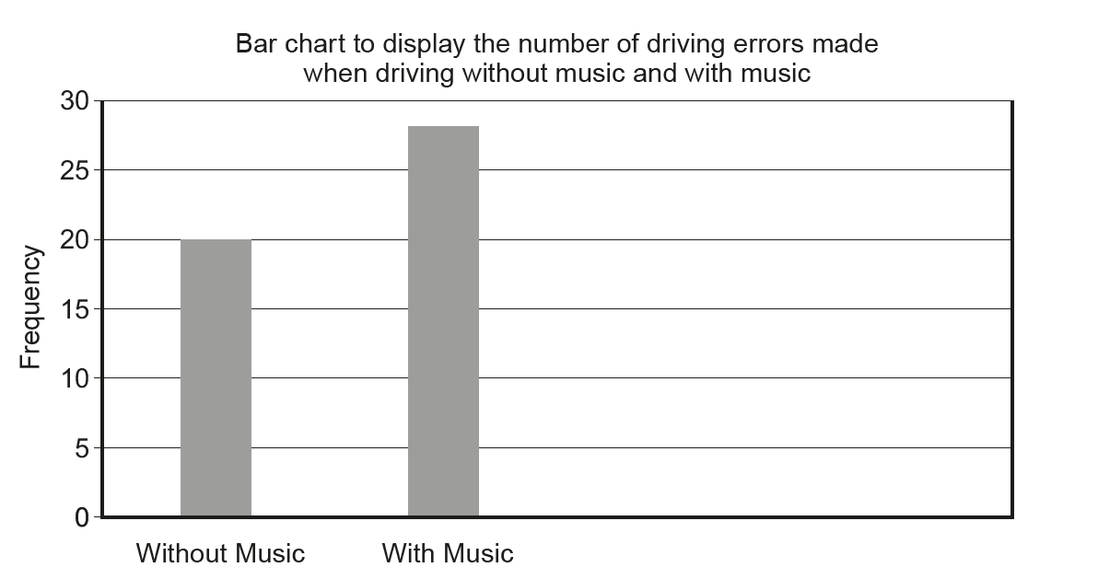

(WJEC PY2, May, 2017)

