Interview

A developmental psychologist was concerned about the amount of time young people seem to spend using social media. She decided to conduct a semi-structured interview with a group of 10-14 year olds. She initially asked her 12 year old neighbour to participate. She then asked the neighbour to recruit two other participants. Each of these participants then also recruited another two participants each. By the end of the research the psychologist had conducted seven semistructured interviews. One question the developmental psychologist asked each participant was ‘How many hours have you spent using social media in the last week?’ The results for this question are displayed in the table below:

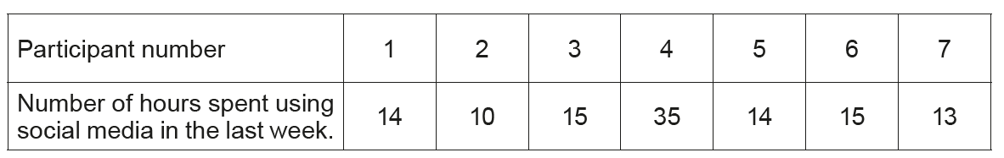

(Eduqas AS Level Component 2, May, 2017)

