Experiment

A Psychology teacher was concerned about the amount of stress her students were experiencing in preparation for their upcoming A level examinations. One month before the examination, she decided to offer her students the opportunity to learn how to meditate. 17 of her students decided to learn how to meditate and practiced meditation for at least 30 minutes per day. 15 of her students decided not to learn how to meditate. As they entered the exam room, she asked each student to rate their stress levels as either ‘no stress’, ‘some stress’ or ‘very stressed’. The psychology teacher decided to compare the stress ratings of those students who meditated with those students who didn’t meditate using a Chi-Square test.

Table of stress ratings of those students who meditated compared with those students who didn’t meditate.

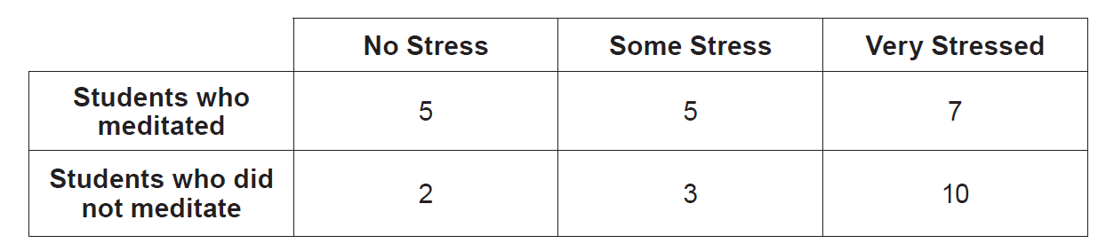

(Eduqas A Level Component 2, June, 2018)

